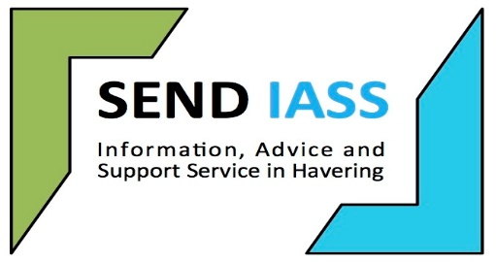

**Havering SENDIASS**

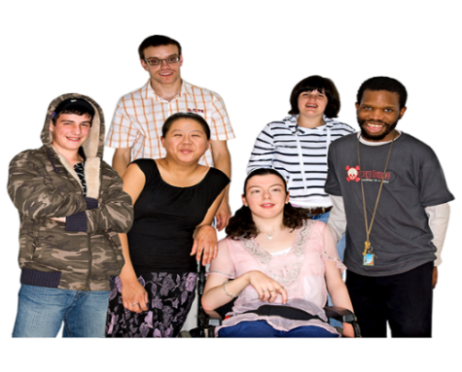

**A guide for young people**

**What we do**

|  |  |
| --- | --- |
|  | **FREE INFORMATION, ADVICE** and **SUPPORT** on matters relating to education, health and social care |
|  | For **CHILDREN** and **YOUNG PEOPLE aged 0-25 with SEND** (special educational needs and disabilities) |
|  | We also offer support to **PARENTS/CARERS** of children with SEND |
|  | We are **IMPARTIAL** which means we are **FAIR** and  **EQUAL** to everyone |

|  |  |
| --- | --- |
|  | We keep your information **CONFIDENTIAL**  If we feel you are **unsafe** and **need extra support**, we can **share your information** with the **safeguarding team** |
|  | You have the **right** as a young person to get your **own advice and support** |

**Havering SENDIASS can**

* + **Listen** to your enquiry
  + Give you **information** about getting the **right support** at school, college or in your training
  + Provide you with **information, advice and support** with your questions about education, health and social care
  + **Talk** with other **professional services** if you need us to
  + Give you **details of other organisations** to help you such as **support groups** or **professional agencies**



**You can contact Havering SENDIASS by**

**🖂 Email**: sendiass@havering.gov.uk

🕾 **Telephone**: 01708 433885

🖳 **Website**: www.haveringsendiass.co.uk