Information about Joining the Dynamic Support Register

This easy read leaflet is about the East Berkshire Dynamic Support Register and deciding if you give your consent to join it.


This easy read leaflet is for children and adults with learning disabilities and or autism who might be at risk of going into a specialist hospital because

of a mental health problem or behaviour which is seen as challenging.

It is also for family carers and other people who can support you to understand what the register is about and if it’s right for you.


Dynamic Support Register
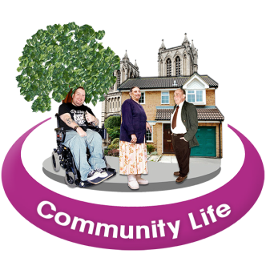
The Dynamic Support Register is about helping you get the right care and treatment in your community whenever possible, by working with you and those who support you.

Most children and adults with mental health problems or challenging behaviour can live well in the community and may never need to go into a specialist hospital for assessment or treatment.


But if you experience a difficult time and your current care is not meeting your needs, you and people who support you will need to think about what extra support you will need.


Often this support can be given locally in the community but sometimes people need to go into a specialist hospital to get better. This form is about making sure you and your carer are included in decisions.

What is the Dynamic Support Register?


The register helps us respond quickly if someone’s care isn’t meeting their needs. It helps make sure options are looked at to stop people reaching crisis point. It helps services work with you to decide what support you may need.

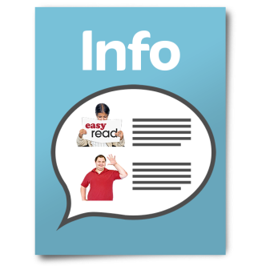
This leaflet gives you information so you can decide if you want your details to be on the register.

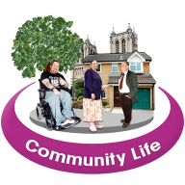

Dynamic Support Register


The register is one of the local changes that is happening to help more people get the support they need to stay in the community so they don’t have to go into hospital.

What are the good things about joining the register?

The register is about helping people get the right support as fast as possible, if they ever need it.

This is because services will know what extra help and support you might need and can plan their support around this. You will be involved in planning your care and support.

What if I don’t want to join?



Your will still get support if you need it.

Is it right for me?

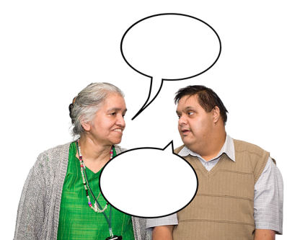
It is a good idea to talk to people who understand your support needs. They will help you understand what the register is about and help you decide if it’s right for you.

What happens if I am on the register?


If you are on the register this means the people who pay for your care can work together and more quickly to think about the support they can offer if your needs increase.

What is consent and why do we
need it?

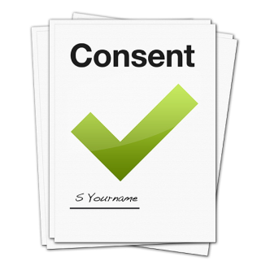
Consent is about understanding the facts so you can decide what’s right for you. Your details only go on the register if you say they can. If you are under 16 your parent will take this decision on your behalf.

- you will receive a copy of the consent form to sign

- you can change your mind at any time

- you can find out what information is being held about you

- you will be asked, at least once a year, whether you still give consent for your information to be held on the register

What will happen to my information?


Your personal information will be kept in a safe place by the Integrated Care Board (ICB) and it will only be shared with you and people who provide your care now or in the future.


Sometimes, anonymous information from the register is safely shared with other parts of the NHS. This information does not include people’s names or any other personal information which could identify anyone.



Dynamic Support Register
This information helps health and social care teams understand what difference the register is making in people’s lives and provide the right kind of services.

What sort of information will the register include?

The information will depend on your care and support needs. It will include information about:

- your name, date of birth and address
- the name and contact details of professionals who are involved in the care and treatment you are receiving
- your health, including mental health
  - things that can make you upset and what helps you feel well
  - anything that people involved in providing your care and support should know to keep you safe


Next steps – giving your consent!

Have you understood the information in this document?

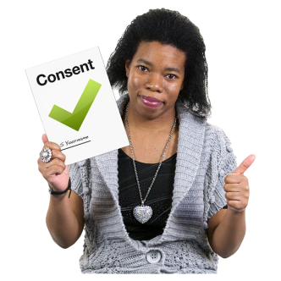

If so, you are ready to fill in the Consent Form to say whether or not you give your consent to be put on the Dynamic Support Register?



Your care co-ordinator or someone involved in supporting you can help you fill it in.

