Annual Reviews

It is the duty of the LA to review statements and EHC plans. Where a child is attending a school or other institution the LA will ask the head teacher or principal to conduct the meeting but ensuring that the overall process takes place, including completing the review by making a decision and notifying this to the parents or the young person is the LA’s responsibility and duty.
The annual review is in fact all the actions taken by the local authority (‘LA’) to formally review the continued applicability of the statement or EHC plan, including its decision after receiving the report of the meeting to maintain the statement/plan as it is, to change it, or to cease it.
Many people think that it is just the meeting that is the Annual Review, but this is only a small part of the whole process.

The Process:
Before the meeting, there are three distinct steps with their own timeframes:
1 LAs tell heads which pupils’ statement and EHC plans must be reviewed in the coming term.
- The head or delegate requests advice from all concerned.
- The head invites all concerned to the annual review meeting, circulating the advice obtained in step 2.
At an unspecified time, but in enough time for the advice to be circulated with the notice for the meeting, the head or their delegate must request/obtain written advice from specified people.
At least two weeks’ notice of the date of the meeting must be given and the advice obtained under step 2 must be circulated to all concerned at least two weeks in advance of the review meeting.
SENDIASS recommend completing the parental views paperwork in good time, be honest and open but try not to dwell on the distant past, this is to review the past 12 months only.
Parents can come to SENDIASS for support in completing the paperwork and for support at the meeting.
The Meeting:
The review for EHCP’s should focus on the desired outcomes for the child/young person, to measure success, looking at the past 12 months

After the Meeting:
Within two weeks of the meeting, the head must prepare and send out a report recommending any changes to the plan, and referring to any difference between those recommendations and recommendations of others attending the meeting.

What next?
The Code of Practice, section 9.176 states:
“Within four weeks of the review meeting, the local authority must decide whether it proposes to keep the EHC plan as it is, amend the plan, or cease to maintain the plan, and notify the child’s parent or the young person and the school or other institution attended.
If the plan needs to be amended, the local authority should start the process of amendment without delay”

Rights of Appeal
A right of appeal in regards to an EHC plan will arise annually as in respect of each of the three options an LA can take after annual review appeal (maintain the plan, amend the plan or cease to maintain the plan).
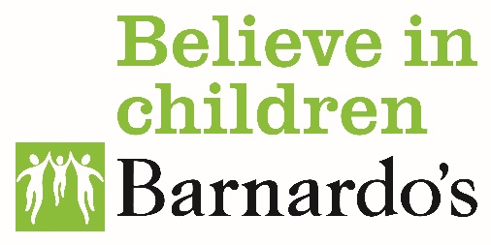
If the LA decides to cease the statement or the EHC plan, they will issue a cease to maintain notice and the parent/young person will be entitled to appeal.

