# Equality Impact Assessment (EIA) FormAfC_CMYK-Forwhitebackground_grey_1000px

Please use in conjunction with the [**EIA toolkit**](https://docs.google.com/document/d/1JEphMGtihGd4ICPeYBSJPLHPGK3jTyGejZOTH8_oyNo/edit?usp=sharing), which has been designed to guide you through completing your EIA form.

Service area Special Educational Needs and Disabilities (SEND)

Name of service/policy/project being assessed Achieving for Children - RBK SEND Futures Plan 2020/21 to 2025/26

Officer leading on assessment Megan Francis-Falkner, SEND Policy and Project Officer

Other officers involved Ashley Whittaker, Programme Director

Henry Kilpin, Head of Strategy, Policy and Programmes

Date of Equality Impact Assessment February 2023

## 1. Briefly describe the service/policy/project:

## The SEND Futures Plan is the transformation programme and the plan sets out how the local area will work with children and young people with SEND and their families to improve our services on a continuous basis, within the financial resources available to us. This plan is an updated version of the SEND transformation programme originally agreed by the Council in February 2019. Like many local authorities across the country, Kingston Council is facing unprecedented financial challenges as a result of sustained reductions to budgets, the increasing and more complex needs of some of the children and young people with SEND in the borough, and continuing statutory duties.

Since February 2019, considerable progress has been made with increasing the quality of several aspects of Kingston’s SEND system, and in more fully implementing the SEND Reforms contained within the Children’s and Families Act 2014. The plan takes these changes into account, focuses on those areas that have not made as much progress and that require additional profile and effort, and sets new targets to maintain the momentum of improvement. The SEND Futures Plan is also Kingston’s Dedicated Schools Grant Deficit Management Plan and ensures that sufficient progress is made against the conditions within the Safety Valve Agreement, agreed between the Department for Education and The Royal Borough of Kingston upon Thames in March 2021 and covering the financial years from 2020-21 to 2025-26. The outcome of the SEND Futures Plan is to reach a positive in-year balance on its Dedicated Schools Grant (DSG) account by the end of 2024-25 and in each subsequent year as well as improving the quality of SEND provision across the borough.

**Background, context and challenges in Kingston**

Approximately 4,000 children and young people with SEND live in or are educated in the borough; with around 1,620 children and young people with an Education, Health and Care plan (EHC plan) to describe the support that has been agreed is needed for their needs to be met. About 7% of these children and young people with EHC plans also receive support from children’s social care, a total of 112 in December 2022, 45 being looked after, 15 having a child protection plan and 52 having a child in need plan.

14.5% of children and young people at Kingston’s primary and secondary schools have SEND, with about 4.5% having an EHC plan, and about 10% are registered for SEN Support.

A disproportionately high number of young people supported by our Youth Offending Service have SEND. The main presenting needs in Kingston’s EHC plans are: autistic spectrum conditions (41%), speech, language and communication needs (21%); and social, emotional and mental health needs (10%). Other needs include hearing impairment, moderate learning difficulty, multisensory impairment, physical disability, profound and multiple learning difficulty, severe learning difficulty, specific learning difficulty (such as Dyslexia) and visual impairment.

In Kingston, the largest proportion of children and young people with EHCPs are educated in mainstream nurseries and schools, 34.3%. 11% of children and young people with an EHCP are educated in either a Specialist Resource Provision (SRP) or resourced provision and 0.4% are educated in alternative provision. 25% of children and young people are being educated in state funded special education; 14% are in post-16 education provision in colleges or vocational schemes, such as traineeships and apprenticeships and 10% of children and young people are educated in independent and non-maintained special schools.

The total number of EHCPs at the end of December 2022 was 1,626 which is a 5.6% increase on 12 months ago. There has been an increase in EHCPs every year since 2014/15. Although this is below the national average increase of 10%, it places significant financial pressure on the Council and its strategic partners. Funding for the local authority to support the education needs of children and young people with SEND, from their early years to age 25, comes from the high needs block of the Dedicated Schools Grant (DSG). The DSG is provided by the government to every upper-tier local authority to fund local early years provision, maintained schools and free schools, as well as educational provision and support for children and young people with SEND. The total DSG for Kingston in 2022/23 before recoupment is £165.245 million of which £29.018 million is allocated for high needs provision. 95% of the high needs block is required for children and young people with EHCPs. The level of DSG for each upper-tier local authority is calculated using a national funding formula including the total size of the child population, the level of deprivation and educational attainment scores; the formula is not adjusted to reflect the prevalence of SEND within the local authority area. Local distribution of DSG funding is managed by the Schools Forum which includes representatives from schools within the borough. The local integrated care system is responsible for funding and arranging support for health needs and the local authority does the same for social care needs.

Some of the key challenges with the delivery of the SEND Futures Plan are listed below:

1. The lack of available specialist places within the borough is resulting in higher cost out of borough placements being selected as appropriate provision for children and young people. The lack of specialist places in surrounding boroughs is increasing the price of placements, and this combined with real increases in costs such as energy and inflation, is increasing overall placement costs. Joint working with the DfE and new providers for capital schemes to increase specialist places will make a significant difference in this area.
2. There continues to be challenges with recruiting professionals into certain roles across the service. Specific examples of this in certain services are: Educational Psychologists, Clinical Psychologists, Occupational Therapists, Physiotherapists, Speech & Language Therapists and SEND Case Workers. There is a risk that shortage of staff will cause a struggle to deliver statutory duties in a timely manner and insufficient capacity, skill and expertise within the service to drive up the quality of work and maximise the benefits. This will impact the progress of the SEND Futures Plan as there may be insufficient capacity or skill in certain areas to drive the agenda forward.
3. The continuation of significant increases in need, complexity of need and the number of requests for EHC needs assessments with a view to receiving a EHC plan from schools and parents. Workstream 4 and 5 action plans will cover all the key actions that need to be taken to ensure that we are closely monitoring the level of needs and issuance of EHC Plans.
4. The uncertainty of the impact of implementation of the Integrated Care System (ICS) on the SEND system. There is uncertainty around the potential impact of the implementation on the health provision with SEND services and what this means for children and young people. There may be an impact on delivery and health provision in the borough moving forward.
5. The uncertainty regarding the funding split between Education, Social Care, Health and Adult Services brings future financial uncertainty and inability to forward plan. This is due to future funding arrangements not being transparent and longer term this will put further financial pressure on the DSG.

**Detailed proposals**

A child or young person (up to the age of 25 years) has a Special Educational Need or Disabilities (SEND) if they have a learning difficulty or disability which calls for special educational provision to be made for him or her.

Kingston’s vision is that: Every child and young person with SEND belongs to a local, inclusive community that provides the education, health and social care support they need to develop their talents and skills, and that empowers them to live a happy and fulfilling life.

For this to be the case, their special educational needs and disabilities need to be identified at the earliest point, support put in place quickly, and their parents and carers kept well informed about the services available. The aspirations for children and young people can be raised through an increased focus on life outcomes, including employment and greater independence.

Our shared principles guide how we will make decisions and work to achieve our vision:

* Co-production. Children and young people and their parents or carers must be fully involved in decisions about their support and what they want to achieve. They must also be listened to and engaged in the design and delivery of strategies, services and the support provided to them. Children and young people have a right to say what they think, have their opinions taken into account and be involved in decisions and planning around their own lives. In the vast majority of cases parents and carers know their children better than anyone, and it is essential that their views and knowledge are incorporated in decisions being made about their child. Parents and carers must be kept well informed about the services that are available to their families.
* Personalisation. Local provision is expanded and improved so that children’s education, health and care needs can be met locally through high quality services that are focussed on achieving the best possible outcomes for children and young people with SEND, promoting their independence and supporting them to live their lives with confidence and resilience.
* Integration. The whole system, with education, social care and health services at the core, works together and with families to understand and respond to children and young people’s needs in a coherent way, with each partner contributing to robust assessments, plans and funding arrangements, and monitoring the impact of their services and support. There is a focus on working better together for children and young people with SEND who may also be vulnerable in other ways, including those who are looked after, missing education, excluded from school, or at risk of exploitation and criminal behaviour.
* Quality. Provision is high quality and delivered by well trained and supported professionals who work effectively together and use evidence to inform their work, promote resilience and achieve positive outcomes for children and young people with SEND; services that cannot demonstrate this positive impact are re-provided or re-commissioned.
* Inclusion. The community is supported to meet the needs of all children and young people by embracing diversity and inclusion, so that all children and young people with SEND have the same opportunity as their peers to play, learn and grow-up all together in their local community.

**Governance of the plan**

To deliver the outcomes specified in the plan, robust governance arrangements are in place that seek full engagement from all partner organisations and promote constructive debate, scrutiny and challenge. The Kingston Health and Wellbeing Board, also referred to as the Kingston Strategic Partnership, strategically oversees the delivery of the plan as it is the forum where leaders from the local health and care system work together to improve the health and wellbeing of the local population.

To drive the progress of the plan, the SEND Partnership Board is chaired by Kingston Council’s Director of Children’s Services, Ian Dodds. The Partnership Board brings together senior leaders from the services responsible for delivering the activities in the plan; parent and carer representatives; headteachers; health and social care provider representatives; and voluntary sector organisations. Children and young people with special educational needs and disabilities contribute to the Board’s work supported by a participation officer from Achieving for Children. The SEND Partnership Board is responsible for ensuring effective engagement from all stakeholders, including families, so that the detail of the plan is informed by their views and the likely impact of change.

The SEND Partnership Board is accountable to the Health and Wellbeing Board (HWB) for the successful coordination and delivery of the plan. The HWB receives a detailed update every six months. Progress may be considered elsewhere also, such as at the Health Overview Panel.

Individual partner organisations will remain subject to their own governance arrangements in relation to the activities allocated to them in the plan, particularly where these require policy changes. For the Council and Achieving for Children, this will be the Council’s People Committee; for the Integrated Care System (ICS) , this will be the Integrated Care Board. CCGs ceased to exist in 2022 and have been replaced by ICSs who are now responsible for local arrangements for health.

The activities in the plan are organised into five workstreams. Each worksteam is jointly led by partners and reports to the SEND Partnership Board. Membership of each workstream varies and includes those with a contribution to make from those across the partnership with responsibilities for, or interest in, delivering transformation across the local SEND system.

The workstreams objectives and activities are set out below:

**Workstream 1**

The co-production and engagement workstream brings together system leaders, family representatives and input from children and young people. The workstream leads on work to empower the partnership and the community to listen and respond to children, young people and families’ views and wishes and work better together to support the best possible outcomes for all children and young people with SEND. The workstream leads on work on engagement and participation of children and young people, with all levels of need, and their families.

This includes:

* Fostering productive, positive and trusting relationships between parents and carers and service commissioners and providers, including with the Parent-Carer Forum, to enable co-production and to understand and evaluate the impact of our transformation activities.
* Review and develop our local approach to enabling and empowering children and young people to have their say in decisions about them and to shape services and strategies that impact on them
* Developing a local approach to provide more opportunities for all children, young people and families to participate in co-production and engagement activities, including families from black and minority ethnic communities, all socio economic groups, and families where parents have special needs and learning disabilities themselves
* Developing local mechanisms for all partners, including parents, carers and young people, and providers, including early years settings, schools and colleges to feedback on the effectiveness of provision, progress towards outcomes and their experience of the process
* Supporting the community to meet the needs of all children and young people by embracing diversity and inclusion, so that all children and young people with SEND have the same opportunity as their peers to play, learn and grow-up all together in their local community.

**Workstream 2**

The Commissioning and Transformation workstream delivers a well informed and strategic joint commissioning approach for Kingston, with forensic financial awareness. It focuses on developing the partnership’s approach to commissioning together to ensure that our local services are able to meet the needs of children and young people with special educational needs. The workstream leads on work to leverage improvements in service quality and maximise value for money from our shared resources through commissioning. The process of designing and commissioning services is done with children and young people and their families from the earliest stage. It draws on shared local intelligence to inform commissioning priorities and activities.

This workstream leads on work to :

* Developing principles and processes that enable commissioning activities to better respond to local need and be strongly focussed on outcomes for children and young people, including developing our local intelligence and considering how different funding models may offer incentives to drive improvements in the quality and efficiency of provision
* Working together and with children, young people and their parents to understand the performance of commissioned services for children and young people with special educational needs and disabilities and the outcomes that they support; and identify priorities to transform services
* Reviewing resourcing allocations across the partnership to understand the contributions required of each partner to meet the needs of children and young people with Education, Health and Care Plans, including jointly funded places for those with complex needs and in out of borough and residential placements
* Working with children, young people and their families, and the leads of Workstream 3, to develop a high quality local therapy offer
* Identifying opportunities to work in commissioning consortiums or other partnership arrangements with other areas to leverage cost savings
* Improving commissioning of placements including building quality assurance mechanisms into its contract management to securing better value for money
* Ensuring that those services commissioned by Public Health reflect the bespoke needs of the SEND population, including the need for tailored advice and support not only for the children and young people themselves, but also for their parents and carers.

## Workstream 3

The local provision workstream will lead the continued development of capacity and quality in local education, health and social care services for children with SEND so that the needs of as many children and young people as possible are met in their local communities, reducing our reliance on schools outside the borough and on higher-cost provision in independent and non-maintained special schools. Where possible, opportunities for integration of education, health and care multi agency support across all ages 0 to 25 years, including the development of co-location and multi agency hubs will be developed.

There are four main areas of work:

* Developing specialist education places in Kingston that are the first choice of children, young people and families, including expanding local specialist resource provisions and opening a new special school for children and young people with autism.
* Supporting children and young people in their preparation for adulthood by planning for transition to adult life from Year 9, and making sure that local provision is sufficient to meet their needs. This includes planning for their health, where they will live, their relationships, control of their finances, how they will participate in the community and achieve greater independence and is structured around the four pillars of Preparing for Adulthood:

○ further and higher education and/or employment – including exploring different employment options

○ independent living – providing choice and control over their accommodation and living arrangements, including supported living

○ participating in society – including having friends and supportive relationships, and participating in, and contributing to, the local community ○ being as healthy as possible in adult life.

Joint work includes an initiative across AfC, Adult Social Care and Housing and Health Services to consider establishing a jointly commissioned 16-25 local campus / provision to meet the needs of young people with SEND

* Establishing a high quality local therapy offer that supports children and young people to make good progress towards their goals and maximise their opportunities for inclusion and independence, including at 16 to 25 years
* Establishing a fully integrated model for supporting children and young people with emotional wellbeing and mental health needs which includes universal support in schools, early years settings and colleges and progresses through to specialist intervention, with specific focus for more vulnerable groups e.g. CYP with disabilities and known to YOS. The “Start Well” section of the Kingston Health and Care Plan , highlights the need to improve the mental wellbeing and resilience of our children and young people and the opportunities that children and young people with special educational needs and disabilities are given to flourish and be independent.

## Workstream 4

The objective of the early intervention and transition workstream is to support families and all agencies including education providers, to where possible prevent additional needs occurring, and where they do arise, to be competent and confident in supporting children and young people with SEND, from the early years to post-16. This will mean that children and young people will have the best possible experiences and their needs are met early without the need for an EHC plan. This requires teamwork across all relevant agencies and the development of a strength and capability focused approach to SEND rather than a deficit-focused model.

**First 1001 Days**

Healthy physical, emotional and social development during the first 1,001 days of life:

* supports secure relationships between young children and their carers
* lays young children’s foundations for lifelong mental and physical health
* means young children feel safe and secure, ready to play, explore and learn
* leaves young children ready to achieve and learn at school
* enables young children to manage their emotions and behaviours
* gives young children the skills to form trusting and caring relationships

The first 1,001 days provides the opportunity for first stage intervention with families to provide support to parents and children so that their needs can be met at the earliest stage and prevent poorer outcomes in later childhood, adolescence and adulthood. Special Educational Needs and Disabilities can be identified and supported at the earliest opportunity, and in some cases prevented. It offers the opportunity to prevent children, young people and adults from requiring support from statutory children’s social care and health services by working in a truly early interventionist and preventative way.

## Early Years onwards

## The majority of children and young people with SEN or disabilities will have their needs met within local mainstream early years’ settings, schools or colleges, without the need for an EHC plan. Education providers are provided with funding for this purpose. A graduated approach to understanding the child or young person’s needs and removing their barriers to learning is used - the “Assess, Plan, Do, Review” cycle.

## High quality teaching that is differentiated and personalised will meet the individual needs of the majority of children and young people. Schools and colleges must use their best endeavours to ensure that such provision is made for those who need it. Special educational provision is underpinned by high quality teaching and “is compromised by anything less” .

## Moving from nursery to primary school, and from there on to secondary school and to college can cause additional challenges for children and young people with SEND. Well planned transitions between phases of education is key to preventing needs from increasing.

## Workstream 5

## The objective of the assessment and planning workstream is to drive improvements in the quality of EHC plans and the annual review process. This includes:

## improving the process for the development of EHCPs, ensuring that plans are completed within statutory timescales to a consistently high standard, promote resilience and independence, include the views of the child or young person and their parents or carer and are based on detailed and well-evidenced assessments by all professionals. Make the statutory process a person-centred, strengths based, outcomes focused one.

## establishing a robust framework for the annual review of EHCPs so that statutory expectations are met, children and young people are fully engaged and the process is inclusive of all stakeholders. There is a thorough review of the outcomes and continuing needs of each child or young person and the provision supports children and young people to make good educational progress and promotes resilience and independence

## establishing effective quality assurance mechanisms for EHCPs that are inclusive of all organisations and professionals contributing to the EHCP in line with the SEND Code of Practice (2014)

## 2. What sources of information have been used in the preparation of this equality assessment? (e.g. national research, JSNA, user feedback)

**Information source** **Description and outline of the information source**

SEND Futures Plan - Kingston SEND Futures Plan Kingston - Transformation programme that sets out how will work with children, young people and their families to improve our services on a continuous basis, within the financial resources available to us.

Kingston Population Data Data relating to general population and school pupil characteristics provided by Kingston Council.

<https://data.kingston.gov.uk/children-and-young-people/#/view-report/ebc6f18fbb1e4fb0a9292c50ff9fa97c/E09000021>

<https://data.kingston.gov.uk/population/#/view-report/4bb61cd8fe294edca63ed3cba7f92f24/E09000021>

Kingston Joint Strategic Needs Assessment <https://data.kingston.gov.uk/jsna/>

Kingston School Census Data Data from the Spring 2022 school census and the Autumn 2022 school census undertaken by the AfC Intelligence team

National SEN2 Data Statistics on pupils with SEND across England <https://www.gov.uk/government/collections/statistics-special-educational-needs-sen>

Kingston Carers Data relating to Kingston Carers and SEND

## 3. Analysis of impact

**NOTE:** This assessment presents data relating to children and young people with an EHCP and also to children and young people with SEND but who do not meet the threshold to have an EHCP and are registered as SEN Support. Under these circumstances the school (or other education setting i.e. nursery if aged under 5 and college if applicable) is responsible for developing an individual SEN support plan to meet their needs. Every mainstream school has a special educational needs coordinator (SENCO) who is responsible for organising extra help for pupils with SEND. The SENCO works with the class teachers and subject teachers to plan the help each child will receive. The school will give clear information about the extra help the child is getting and should meet with the parents/ carers at least three times a year to review how the child is progressing and what the next steps will be. The school should also provide a report at least once a year on the child's progress.

The data presented is the latest available for children and young people receiving SEN Support being from the 2022 autumn census and the 2022 spring school census. The data presented for children and young people with an EHCP is from 31st December 2022.

**Age**

**Impact:** Positive.

The SEND Futures Plan and the work that is encompassed within it are considered extremely relevant to age given that the plan relates specifically to children and young people with SEND aged 0-25 years old. The impact is deemed to be positive as the SEND Futures Plan is a strategic plan to transform the SEND services that are provided to children and young people and improve outcomes for them.

The data shows that the proposals are likely to have a greater impact on those aged 11-15 who have an EHCP in the current cohort as this is also the most common age grouping for those with an EHCP in Kingston and nationally. The number of children and young people that have plans between the age ranges: 5-10 years old, 11-15 years old and 16+ years old are fairly similar and therefore it would be deemed it would have an impact on children and young people aged 5 - 25 years old.

For those receiving SEN Support, the age group most likely to be impacted are those aged 5 to 10 years old. This aligns with national data that shows SEN Support declines as age increases. Those aged ten and under receiving SEN Support are therefore most likely to be impacted by the SEND Futures Plan as they account for 60.7% of the cohort. There is a growing cohort aged 11-15 years old.

**Data and analysis:**

**Education, Health and Care Plans (EHCPs)**

As of the end of December2022, Kingston was responsible for 1,626 EHCPs.

The numbers in each age group are set out below:

0 - 4 years old: 21

5 - 10 years old: 547

11 - 15 years old: 621

16+ years old: 437

Of the above age ranges, children and young people (CYP) aged 9-11 years old have the highest proportion of EHCPs, however the age ranges from 12-14 and 15-17 years old are also fairly similar as stated above.

The list below set outs the number of children and young people per school year group/age group post 19:

Nursery 1-2 years old: 0

Nursery 2-3 years old: 7

Reception: 28

Year 1: 52

Year 2: 85

Year 3: 86

Year 4: 90

Year 5: 129

Year 6: 130

Year 7: 140

Year 8: 106

Year 9: 112

Year 10: 135

Year 11:117

Year 12: 104

Year 13: 102

Year 14: 65

Age 19+: 33

Age 20+: 31

Age 21+: 28

Age 22+: 25

Age 23+: 12

Age 24+: 9

Age 25+: 0

The chart below shows the breakdown of EHC Plans across Kingston by school year and age range.

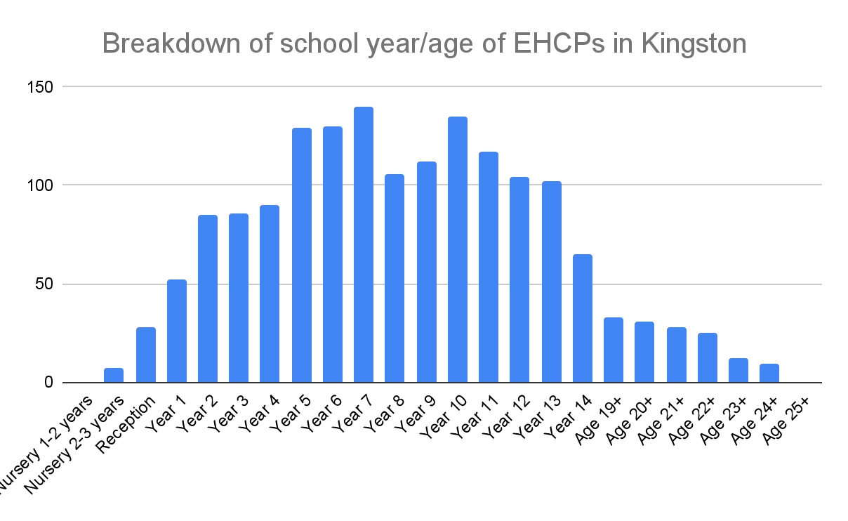

**SEN Support**

The autumn census shows that there were 2,704 pupils receiving SEN support in Kingston, which is 10% of the total school population in Kingston.

Of these, children aged 5 to 10 are the largest age group receiving SEN support, 54.4%, followed by children and young people aged 11-15, 34.3%. Only 6.4% are aged 4 and under.

The numbers in each age group are set out below:

0 - 4 years old: 172

5 - 10 years old: 1471

11 - 15 years old: 928

16+ years old: 133

The list below set outs the number of children and young people who are receiving SEN support per school year group:

Nursery 1-2 years old: 11

Nursery 2-3 years old: 74

Reception: 153

Year 1: 205

Year 2: 221

Year 3: 251

Year 4: 295

Year 5: 243

Year 6: 272

Year 7: 166

Year 8: 207

Year 9: 168

Year 10: 200

Year 11: 144

Year 12: 42

Year 13: 51

Year 14: 1

The chart below shows the breakdown of children and young people receiving SEN support across Kingston by school year and age range.

**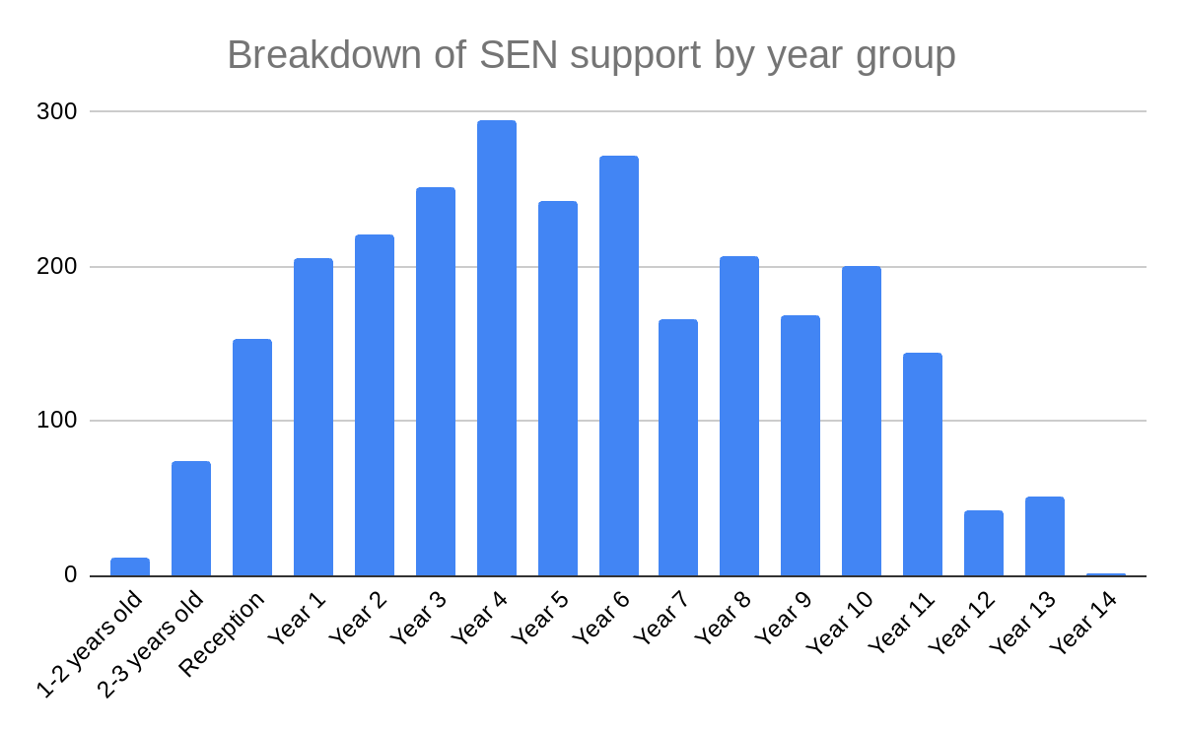**

**Disability**

**Impact:** Positive

The SEND Futures Plan and the work that is encompassed within it are considered extremely relevant to age given that the plan relates specifically to children and young people with SEND. The impact is deemed to be positive as the SEND Futures Plan is a strategic plan to transform the SEND services that are provided to children and young people and improve outcomes for them.

The most common type of need for those with an EHCP in Kingston aligns with national data. This means that those with Autism are most likely to be impacted by the work that is carried out in the SEND Futures Plan as this forms the largest group in the SEND Cohort.

**Data and analysis:**

**EHCPs**

By the end of December 2022 Kingston was responsible for 1,626 EHCPs. The main presenting need is Autistic Spectrum Condition (ASC) (42%), in the last 12 months the number of plans with ASC as the main presenting need has increased by 9%. ASC is followed by Speech, Language and Communication Needs (21.0%) and Social, Emotional and Mental Health (10%). The list below sets out the needs across the cohort of the children and young people with SEND in Kingston.

Autistic Spectrum Condition: 681, 42%

Speech, Language and Communication Needs: 353, 21.7%

Specific Learning Difficulty: 98, 6%

Moderate Learning Difficulty: 117, 7.2%

Severe Learning Difficulty: 40, 2.4%

Profound & Multiple Learning Difficulty: 24, 1.5%

Physical Disability: 60, 3.7%

Visual Impairment: 19, 1.8%

Hearing Impairment: 24, 1.5%

Multi-Sensory Impairment: 5, 0.3%

Social, Emotional and Mental Health: 163, 10%

Other Difficulty/ Disability: 41, 2.5%

The chart below shows the breakdown of main presenting needs in the borough for children and young people with an EHC Plan.

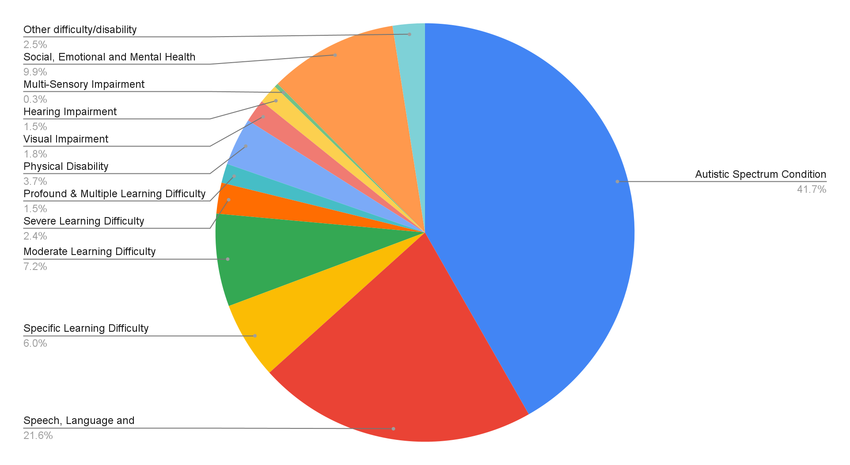

**SEN Support**

10%of pupils in Kingston’s overall school population receive SEN support compared to 12.2% nationally.

At the primary phase 12.1%% of pupils receive SEN support compared to 15% nationally. At secondary phase, 7.7% receive SEN support, compared to 11.6% nationally.

The most common needs of these pupils are:

Speech, Language and Communication Needs: 708

Specific Learning Difficulty: 486

Social, Emotional and Mental Health: 424

Autism Spectrum Condition (ASC): 380

The chart below gives the breakdown for the main presenting need for children and young people who are receiving SEN support in the borough.

**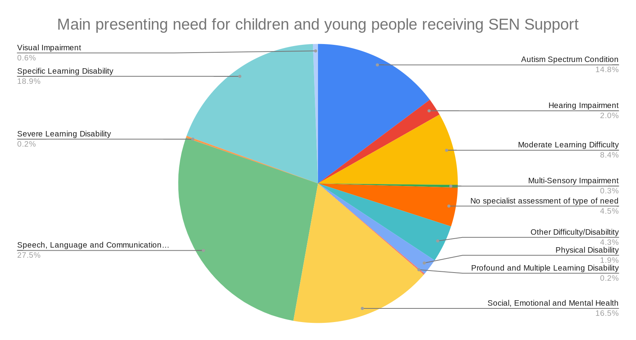**

**Gender (sex)**

**Impact:** Positive

The SEND Futures Plan and the work that is encompassed within it are considered relevant to gender. The impact is deemed to be positive as the SEND Futures Plan is a strategic plan to transform the SEND services that are provided to children and young people and improve outcomes for them.

Given the gender breakdown in the SEND cohort, the proposals, if implemented, would have more of an impact on males than females. This aligns with national data both for those with EHCPs and those receiving SEN Support.

There is an awareness that SEND may be underdiagnosed with the female cohort and there is an awareness of this within the SEND system. Data in Kingston is showing that the percentage difference in plans between males and females is decreasing slowly in recent years which could be a result of being aware of females and SEND underdiagnosis.

**Data and analysis:**

**EHCPs**

At the end of December 2022, Kingston was responsible for 1,626 EHCPs. There is a significant gender split with a much higher proportion of EHCPs issued to males, 70%, than females, 30%.

**SEN support**

Of the 2,704 children and young people receiving SEN support 1758, are male and 946 are female.

Both SEN support and EHCP data on gender in Kingston follows the national trend of SEN being more prevalent in males than females. National data shows that 73.1% of pupils with an EHCP are boys, this trend unchanged from last year. 64.2% of pupils with SEN support are boys, however this has been decreasing slowly in recent years.

**Gender reassignment**

**Impact:** Low/ None

**Data and analysis:**

The proposals are considered to be of low relevance to gender reassignment.

Although data is not currently collected relating to gender reassignment, anecdotal evidence from schools in the borough has indicated a growing level of need in this regard; this is more apparent in secondary schools within the borough. There is awareness that as this cohort of young people spans to 25 years old that this protected characteristic will become of more relevance as young people get older. At present there is not enough sufficient data to analyse the impact on this cohort however it is recognised that the impact of this protected characteristic is to be monitored.

**Marriage and civil partnership**

**Impact:** Low/ None

**Data and analysis:**

The SEND Futures Plan is considered to be of low relevance to marriage and civil partnership. There is awareness that as this cohort of young people spans to 25 years old that this protected characteristic will become of more relevance as young people get older. At present there is not enough sufficient data to analyse the impact on this cohort however it is recognised that the impact of this protected characteristic is to be monitored.

**Pregnancy and maternity**

**Impact:** Low/ None

**Data and analysis:**

The SEND Futures Plan is considered to be of low relevance to pregnancy and maternity. There is awareness that as this cohort of young people spans to 25 years old that this protected characteristic will become of more relevance as young people get older. At present there is not enough sufficient data to analyse the impact on this cohort however it is recognised that the impact of this protected characteristic is to be monitored.

**Race/ethnicity**

Impact: Positive

The SEND Futures Plan and the work that is encompassed within it are considered relevant to race/ ethnicity. The impact is deemed to be positive as the SEND Futures Plan is a strategic plan to transform the SEND services that are provided to children and young people from all backgrounds and improve outcomes for them. There is an awareness that this protected characteristic may be underrepresented with regards to feedback received and involvement in co-production, participation and engagement. There is on-going work within the SEND service to ensure that the voice of the children and young people and their families from all ethnic backgrounds are heard and that these groups are not underrepresented.

Based on the information available, there does not appear to be a disproportionate impact on any specific ethnic group. The service will continue to improve the collection of this data so a clearer understanding of impact on different ethnicities is possible.

**Data and analysis:**

33.0% of all residents in Kingston are from a Black, Asian or Minority Ethnic (BAME) background. Between 2017 and 2020, the proportion of Kingston’s resident population from BAME groups has increased from 31.0% to 33.0%, and this growth is expected to continue to 46.0% in 2036.

It is also worth considering that the relationship between ethnicity and SEND is complex, with many other variables such as socio-economic status, language and cultural barriers influencing children’s outcomes.

At an aggregate level, the national School Census, from January 2021, shows the following statistics regarding ethnicity for children and young people with an EHCP. Data has been collected for 303,668 children and young people with an EHCP in England. There are currently 430,697 EHCPs in England which means that ethnic data for 127,029, 29% of the cohort was not collected compared to Kingston population of 26% not collected/ refused.

White: 220,763, 72.7%

Mixed: 19,865, 6.5%

Asian: 30,201, 9.9%

Black: 21,013, 6.9%

Chinese: 998, 0.3%

Other: 10,828, 3.7%

**EHCPs**

The table below sets out the race/ ethnicity of the 1,626 children and young people with an EHCP.

White: 924, 56.8%

Mixed: 185, 11.4%

Asian: 199, 12.2%%

Black: 69, 4.2%

Other: 76, 4.7%

Not obtained/ Refused: 173, 10.6%

Of those whose race/ ethnicity is known, 63.6% are White. The next largest group is Asian, 13.7%, and those of mixed ethnicity, 12/7%.

The chart below shows the breakdown of race/ethnicity of the 1,626 of children and young people with an EHCP that we have ethnicity data for, this is to give a proportional representation of this cohort however we are aware that there is a large number of children and young people that we have not collected from are this may skew the data.

**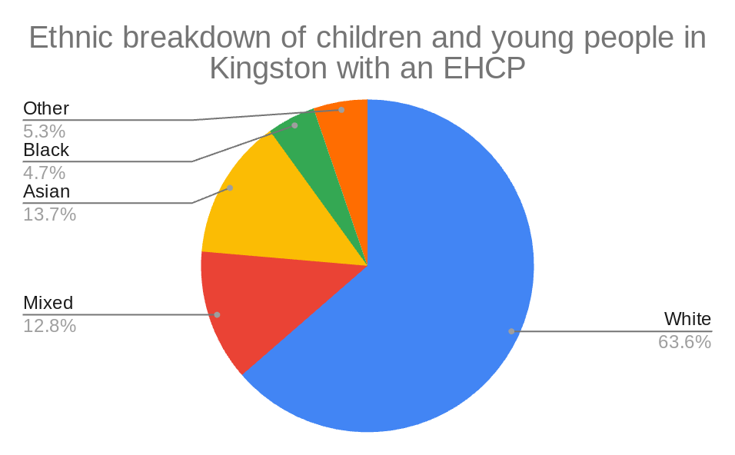**

**SEN Support**

White: 1,736, 67.4%

Mixed: 304, 11.8%

Asian: 297, 11.5%

Black: 67, 2.6%

Other: 124, 4.8%

Not obtained/ Refused: 47, 1.9%

Of the 2,575 children and young people receiving SEN support, 55% (1,423) are White British and 45% are BAME.

The chart below shows the breakdown of race/ethnicity for the 2,575 children and young people in the borough who are currently receiving SEN support.

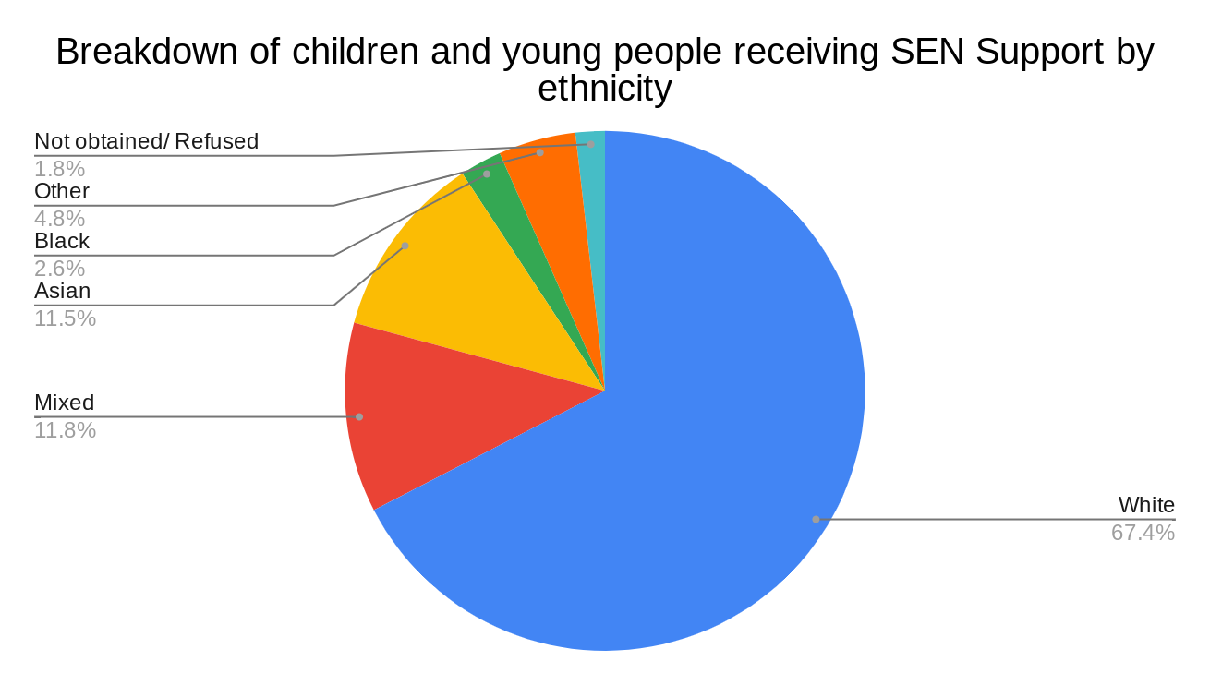

At an aggregate level, the national School Census shows the following statistics regarding ethnicity for children and young people who receive SEN support. Data has been collected for 1,002,442 children and young people with an EHCP in England.

White: 765,042, 76.3%

Mixed: 62,197, 6.2%

Asian: 85,341, 8.5%

Black: 55,828, 5.6%

Chinese: 2,032, 0.2%

Other: 32,002, 3.2%

**Religion and belief including non-belief**

**Impact:** Low/ none

**Data and analysis:**

The SEND Futures Plan is considered to be of low relevance to religion and belief.

**Sexual orientation**

**Impact:** Low/ None

**Data and analysis:**

The SEND Futures Plan is considered to be of low relevance to sexual orientation. There is awareness that as this cohort of young people spans to 25 years old that this protected characteristic will become of more relevance as young people get older. At present there is not enough sufficient data to analyse the impact on this cohort however it is recognised that the impact of this protected characteristic is to be monitored.

**Other i.e. carer, or those on a low income**

Impact: Low

**Data and analysis:**

Data from Kingston Carers from December 2022 shows that 171 out of 927 young carers registered have SEND, this is 18.4% which is higher than the percentage of children and young people with SEND in Kingston at 14.5%.

There is a recognised link between low socio-economical status and SEND. National data shows that pupils who qualify for free school meals (an indicator of deprivation) are much more likely to have SEND. In the year 2021/2022, of the pupils in England eligible for free school meals, 36.4% received SEN support, and 39.7% had an EHCP.

At present there is not enough sufficient data to analyse the impact on this cohort locally however it is recognised that the impact of this protected characteristic is to be monitored. Once the data has been collated then analysis can be completed to evaluate the true impact locally.

## 4. What consultation have you undertaken in the development of this policy/project or with stakeholders or critical friends? Outline the consultation method and what feedback has been received:

An initial consultation was taken upon the SEND Transformation Plan and then the changes to the SEND Futures Plan which was documented in the original Equalities Impact Assessment. Since then a co-production commitment has been agreed by AfC, ICS, the Local Authority and the Parent Carer Forum; this co-production commitment means that there is a commitment to ensure that individual needs are optimally met, and crucial insights are obtained into how services and outcomes can be improved. For this to happen, all partners need to engage with children and young people with SEND and their parents and carers on decisions about their own support, and on services offered across the wider system.

Children and young people and their families are communicated throughout the academic year through different surveys, consultations and in meetings to ensure that the progress of this plan is capturing the voice of children and young people with SEND and their families. A Parent Carer Engagement Officer has been appointed to develop closer working relationships with families across the borough and to ensure that parents and carers of children and young people with SEND are involved in the SEND Futures Plan. The Parent Carer Engagement Officer also meets the Parent Carer Forum’s steering group on a regular basis. A new SEND Participation Officer has also been recently employed who will engage and consult with children and young people with SEND to ensure that their views are heard and reflected in the SEND Futures Plan. There is an awareness that communication with parents and carers and children and young people could be improved and one of the main objectives of the Parent Carer Engagement Officer is to improve this.

Monthly parent carer consortium meetings are held with parents and carers, the Parent Carer Forum, AfC colleagues and representatives from the SEND system including the ICS, Adult Social Care and other organisations. These meetings provide an opportunity for individual parents/carers of children with SEND, and members of the Kingston SEND Parent Carer Forum to discuss important topics with members of senior staff, who are responsible for providing SEND children’s services for Kingston Council. [Meeting notes from these meetings](https://kr.afcinfo.org.uk/pages/local-offer/information-and-advice/participation-and-involvement-activities/kingston-send-parent-consortium) are held on the Local Offer website available for everyone to view.

A number of different consultations relating to Kingston’s SEND system have taken place between 2019-2022, and these were described in the [report to the People committee in November 2020.](https://moderngov.kingston.gov.uk/documents/s89944/SEND%20Futures%20Plan.pdf)

## 5. Summary of findings

After analysing the data collected for each protected characteristic alongside the impact of the SEND Futures Plan on these protected groups the overall impact of this plan is positive. The aim of the plan is to improve the quality of SEND provision across Kingston whilst ensuring financial sustainability and the work that is being carried out to transform these services are positive.

Some of the findings below are to be recognised as areas to be aware of throughout the work that is being progressed with the SEND Futures Plan:

* There is an awareness that SEND may be underdiagnosed with the female cohort and there is an awareness of this within the SEND system. Data in Kingston is showing that the percentage difference in plans between males and females is decreasing slowly in recent years which could be a result of being aware of females and SEND underdiagnosis
* Children and young people who are from ethnic minorities may be underrepresented with regards to feedback received and involvement in co-production, participation and engagement. There is on-going work within the SEND service to ensure that the voice of the children and young people and their families from all ethnic backgrounds are heard and that these groups are not underrepresented.
* The following protected characteristics: gender reassignment, pregnancy and maternity, sexual orientation and marriage and civil partnership may become more prevalent in the older cohort of children and young people with SEND. Therefore the impact on the protected characteristics may change, at present data is not available for any impact this may have.
* Positively, the number of families with a child with an EHCP who have not provided information about their race/ethnicity has dropped from 26% in March 2022 to 10% in December 2022. However, given that information on 10% of children and young people about their race/ ethnicity is still not held, we may not have a true understanding of the impact on this cohort. The service will continue to improve the collection of this data so a clearer understanding of impact on different ethnicities is possible.

## 6. Action planning

What consultation have you undertaken with stakeholders or critical friends about the key findings? Include any identified data gaps:

Issue identified **(1)** Lack of ethnicity data in relation to children and young people with EHCPs

Planned action Improve data collection in relation to the ethnicity of children and young people with EHCPs

Lead officer Head of SEND

Completion date On-going

Issue identified **(2)** Ensuring that parents and parent representatives are informed

Planned action Parent Carer Engagement Officer to work with colleagues, the Parent Carer Forum and parents to ensure that parents and carers are informed of development in SEND provision across Kingston

Lead officer Parent Carer Engagement Officer, AfC colleagues to assist

Completion date On-going

Issue identified **(3)** Children and young people who are from ethnic minorities may be underrepresented with regards to feedback received and involvement in co-production, participation and engagement.

Planned action Parent Carer Engagement Officer to work with colleagues, the Parent Carer Forum and parents to ensure that we are receiving feedback, engagement and participation from children and young people and their families from ethnic minority backgrounds

Lead officer Parent Carer Engagement Officer, AfC colleagues to assist

Completion date On-going

Issue identified **(4)** We recognise that the following protected characteristics: gender reassignment, sexual orientation, pregnancy and maternity, carers and marriage/ civil partnership become more apparent as children and young people become older, especially post-16 years old. Information collection needs to improve to better understand the effect this could be having on this cohort

Planned action Information to be collated on these protected characteristics, the age range of this data will need to be considered as it is not applicable to all age ranges. Once this information has been collected further analysis is to be completed to ensure that we understand the impact on this cohort

Lead officer 14-25 PfA SEND Service Manager

Completion date On-going

Issue identified **(5)** At present there is not enough sufficient data to analyse the impact on carers and low income families locally however it is recognised that the impact of this protected characteristic is to be monitored and local data collected and analysed.

Planned action Information to be collated on this cohort. Once this information has been collected further analysis is to be completed to ensure that we understand the impact on this cohort

Lead officer Head of Children, Youth & Partnerships and Head of Intelligence and Improvement

Completion date On-going

## 7. Publishing the completed Equality Impact Assessment

Completed date 28/02/2023

Lead officer Megan Francis-Falkner

Signed off by (Director level)

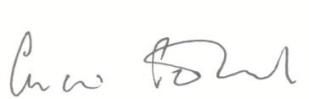

**Charis Penfold**

Please send your completed EIA to [policies@achievingforchildren.org.uk](mailto:policies@achievingforchildren.org.uk) for publication.