My Support Plan (MSP)

# My Support Plan (MSP)

CLICK FOR GUIDANCE

|  |  |  |
| --- | --- | --- |
|  | My preferred name is: | Click or tap here to enter text. |
|  | I was born on: | Click or tap to enter a date. |
|  | My school: | Click or tap here to enter text. |
|  | My year group: | Choose an item. |
|  | My class teacher/form tutor: | Click or tap here to enter text. |
|  | Plan start date: | Click or tap to enter a date. |
|  | Plan review date 1: | Click or tap to enter a date. |
|  | Plan review date 2: | Click or tap to enter a date. |
|  | Plan review date 3: | Click or tap to enter a date. |
|  | Code of Practice | Click or tap here to enter text. |

# A: My One Page Profile

CLICK FOR GUIDANCE

|  |  |  |
| --- | --- | --- |
| **What is important to me: (give choices/prompts as appropriate)** | | |
| **People:** | **Places:** | **Things:** |
| Click or tap here to enter text. | Click or tap here to enter text. | Click or tap here to enter text. |

|  |  |  |
| --- | --- | --- |
| **My aspirations and goals** |  | **What people like and admire about me** |
| **What I would like to be good at:** |  | **What my family like about me:** |
| Click or tap here to enter text. |  | Click or tap here to enter text. |
| **My hopes/dreams/ambitions for the future are:** |  | **What my friends like about me:** |
| Click or tap here to enter text. |  | Click or tap here to enter text. |
| **What I hope to do when I leave school:** |  | **What my teachers like about me:** |
| Click or tap here to enter text. |  | Click or tap here to enter text. |
| **Sometimes I worry about:** |  | **What I like about myself:** |
| Click or tap here to enter text. |  | Click or tap here to enter text. |

|  |  |  |  |
| --- | --- | --- | --- |
| **Things I find hard:** | **What helps me:** | **What does not help me:** | |
| Click or tap here to enter text. | Click or tap here to enter text. | Click or tap here to enter text. |

# B: My Personal Details

CLICK FOR GUIDANCE

|  |  |
| --- | --- |
| Full name: | Click or tap here to enter text. |
| Home language: | Click or tap here to enter text. |
| Gender: | Choose an item. |
| Ethnicity: | Choose an item. |
| If other, please specify: | Click or tap here to enter text. |
| Primary area of need: | Choose an item. |
| Social Care Needs:  *(Choose all that apply)* | Common Assessment Framework  Child in Need  Child Protection  Child in Care  Other |
| Other identified needs:  *(Choose all that apply)* | Communication and Interaction  Cognition and Learning  Social, Emotional, Mental Health  Physical and/or Sensory  Autistic Spectrum Conditions  Other |
| SCERTS Assessment and Plan: | Choose an item. |
| Behaviour/Pastoral Support Plan: | Choose an item. |
| Health Needs relating to SEND: | Click or tap here to enter text. |

|  |  |  |  |
| --- | --- | --- | --- |
| Name and dates of school settings attended | | | |
| Key Stage | School | From | To |
| Preschool | Click or tap here to enter text. | Click or tap to enter a date. | Click or tap to enter a date. |
| KS1/KS2 | Click or tap here to enter text. | Click or tap to enter a date. | Click or tap to enter a date. |
| KS3/KS4 | Click or tap here to enter text. | Click or tap to enter a date. | Click or tap to enter a date. |
| KS5/Post 16 | Click or tap here to enter text. | Click or tap to enter a date. | Click or tap to enter a date. |

# C: Summary of Identified Barriers to Learning/Identified Needs

CLICK FOR GUIDANCE

|  |
| --- |
| Click or tap here to enter text. |

# D: My Circle of Support

CLICK FOR GUIDANCE

## My Family’s Views (indicate the person whose views are being represented & their relationship to the child)

|  |
| --- |
| Click or tap here to enter text. |

## Professionals supporting me and my family

|  |  |  |  |  |
| --- | --- | --- | --- | --- |
| **Name, Role & Agency** | **Contact details (telephone/email)** | **Date(s) of involvement** | **Report (Y/N)** | **Currently involved (Y/N)** |
| Click or tap here to enter text. | Click or tap here to enter text. | Click or tap here to enter text. | Choose an item. | Choose an item. |
| Click or tap here to enter text. | Click or tap here to enter text. | Click or tap here to enter text. | Choose an item. | Choose an item. |
| Click or tap here to enter text. | Click or tap here to enter text. | Click or tap here to enter text. | Choose an item. | Choose an item. |
| Click or tap here to enter text. | Click or tap here to enter text. | Click or tap here to enter text. | Choose an item. | Choose an item. |

## Any informal family/community support

|  |  |  |
| --- | --- | --- |
| **Activity** | **With whom** | **When** |
| Click or tap here to enter text. | Click or tap here to enter text. | Click or tap here to enter text. |
| Click or tap here to enter text. | Click or tap here to enter text. | Click or tap here to enter text. |
| Click or tap here to enter text. | Click or tap here to enter text. | Click or tap here to enter text. |

# E: My Attainments, Assessments and Progress

CLICK FOR GUIDANCE

## *Delete tables that do not apply*

## Early Years Outcomes (indicate age band and whether Emerging (E), Developing (D) or Secure (S)

|  |  |  |  |  |  |  |
| --- | --- | --- | --- | --- | --- | --- |
| **Area of Learning** | **Autumn 1 baseline** | **Autumn 2** | **Spring 1** | **Spring 2** | **Summer 1** | **Summer 2** |
| Personal, Social & Emotional | Choose an item. | Choose an item. | Choose an item. | Choose an item. | Choose an item. | Choose an item. |
| Communication and Language | Choose an item. | Choose an item. | Choose an item. | Choose an item. | Choose an item. | Choose an item. |
| Physical Development | Choose an item. | Choose an item. | Choose an item. | Choose an item. | Choose an item. | Choose an item. |
| Literacy | Choose an item. | Choose an item. | Choose an item. | Choose an item. | Choose an item. | Choose an item. |
| Mathematics | Choose an item. | Choose an item. | Choose an item. | Choose an item. | Choose an item. | Choose an item. |
| Understanding the World | Choose an item. | Choose an item. | Choose an item. | Choose an item. | Choose an item. | Choose an item. |
| Expressive Arts and Design | Choose an item. | Choose an item. | Choose an item. | Choose an item. | Choose an item. | Choose an item. |

## Progress in Key Stage 1 and Key Stage 2

|  |  |  |  |  |  |  |
| --- | --- | --- | --- | --- | --- | --- |
| **Area of Learning** | **End of KS1 Attainment** | | **Summer** | **Autumn** | **Spring** | **Summer** |
| Reading |  | |  |  |  |  |
| Writing |  | |  |  |  |  |
| Maths |  | |  |  |  |  |
| Science |  | |  |  |  |  |
|  | | *Include a key to explain school assessment and attainment data where required* | | | | |

## Attainment 8: Key Stage 3 and Key 4

|  |  |  |  |  |
| --- | --- | --- | --- | --- |
|  | **Summer** | **Autumn** | **Spring** | **Summer** |
| Progress 8 Score |  |  |  |  |
| Attainment 8 Score |  |  |  |  |
|  |  |  |  |  |
| English |  |  |  |  |
| Maths |  |  |  |  |
| Science |  |  |  |  |
| *\*or attach SIMS table* | | | | |

## Attainment: Key Stage 5

|  |  |  |  |  |
| --- | --- | --- | --- | --- |
| **Subject** | **Summer** | **Autumn** | **Spring** | **Summer** |
|  |  |  |  |  |
|  |  |  |  |  |
|  |  |  |  |  |
| *Track value added score* | | | | |

# F: My Outcomes and Review

CLICK FOR GUIDANCE

|  |  |  |  |
| --- | --- | --- | --- |
| Name | Click or tap here to enter text. | | |
| Start Date | Click or tap to enter a date. | Review Date: | Click or tap to enter a date. |
| MSP Version no: | Click or tap here to enter text. | | |

## Long Term Outcomes (end of Key Stage)

|  |  |
| --- | --- |
| **Area of Need** | **Outcomes** |
| Choose an item. |  |
| Choose an item. |  |
| Choose an item. |  |

## Short Term Outcomes (Termly)

|  |  |  |  |  |  |  |
| --- | --- | --- | --- | --- | --- | --- |
| )**Area of Need** | **Description of Baseline Level** | **Baseline level**  **rating** | **Short Term Outcome Expected** | **Steps to success** | **Outcome rating achieved at review** | **Description of level achieved** |
| Choose an item. |  | Choose an item. |  |  | Choose an item. |  |
| Choose an item. |  | Choose an item. |  |  | Choose an item. |  |
| Choose an item. |  | Choose an item. |  |  | Choose an item. |  |
| Choose an item. |  | Choose an item. |  |  | Choose an item. |  |

# G: Consent and signatures

CLICK FOR GUIDANCE

Please sign below to indicate that you:

* Have contributed to the development of the plan.
* Understand the support that will be provided through the plan.
* Agree to a photo of the child or young person being used on the cover of the plan.
* Agree to a copy being stored in the School SEN files and Local Authority, as required.
* Consent to a copy of the plan being shared with the people listed in the ‘My Circle of Support’ section of this plan and with the Local Authority SEN Team, as required.

|  |  |  |  |
| --- | --- | --- | --- |
| **Name** | **Signature** | **Date** | **Role** |
|  |  | Click or tap to enter a date. | Young Person (if appropriate) |
|  |  |  | Parent/Carer |
|  |  |  | School representative/MSP author |

My Support Plan (MSP)

## A Guide for Completion

This guide tells you all you need to know about the Barnet My Support Plan, when to complete one and how to go about the process.

* Section 1 provides an overview of the process, outlining the key actions and decisions that you need to make.
* Section 2 provides an overview of the My Support Plan documentation and guidance on how to complete it.
* Appendices provide useful templates and proformas to help you through the process.

# Section 1

# What is an SEN Support Plan?

An SEN Support Plan is a **holistic** plan for children and young people with additional needs who do not meet the statutory criteria for an Education, Health and Care Plan (EHCP). It has been developed for children and young people aged 0 to 25 years.

We are recommending that a My Support Plan (MSP) is completed for all children or young people with identified special educational needs (SEN). This means they require provision that is *different from* or *additional to* that normally available to pupils of the same age (SEND Code of Practice, 2015, 6.15).

The Barnet ‘My Support Plan’ is a template for children and young people identified at **SEN Support**. However, you may wish to adapt and use this for children and young people undergoing a Statutory Assessment or with an Education Health and Care Plan.

The purpose of the MSP is to help children or young people to achieve the outcomes or learning objectives set for them by the school or setting. Parents and young people should be involved in this process, where appropriate.

The Barnet MSP form is part of an exemplar framework. It is for settings to determine their own approach to record keeping in line with the requirements of the Data Protection Act 1998.

The provision made for children or young people with SEN should be recorded accurately and kept up to date. As part of any inspection, Ofsted will expect to see evidence of **pupil progress and attainment over time**, a focus on **outcomes** and a rigorous approach to the **monitoring and evaluation of SEN provision**.

The Barnet MSP reflects the four-stage cycle of **Assess – Plan – Do – Review** and involves parents and the child or young person at the earliest stage. The graduated approach should ensure that earlier decisions and actions are revisited, refined and revised with a growing understanding of needs and what supports the child or young person to make good progress and secure good outcomes.

It draws on more detailed approaches, more frequent review and more specialist expertise, in successive cycles to match interventions to the identified and assessed needs.

# An Overview of the My Support Plan (MSP) process

What to do when you believe a student may benefit from a MSP

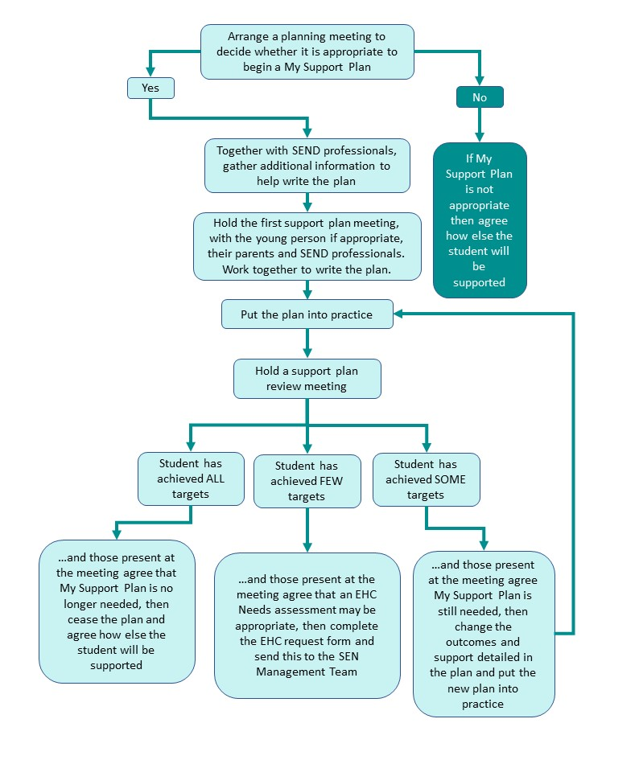

At or before the first My Support Plan meeting the ‘Hello and Welcome’ leaflet can be given to parents/carers and student to explain the process. See Appendix 1*.*

# Section 2

# Guidance for Title Page

* Insert an image (photo, picture or drawing) in the box if desired or school logo; delete it, if not. *\*Check with your school Data Protection Officer (DPO) when inserting a child or young person’s photo to ensure that it is in line with the new General Data Protection Guidance (GDPR).*
* Add personal details including the name of the early years setting, school or college attended and current year group.
* Plan Start Date is the date for the first My Support Plan meeting. Plan Review Date 1 is the date of the first review meeting. Add subsequent termly plan review dates for the academic year.
* See Appendix 6 for a suggested table to track meetings.

BACK TO TITLE PAGE

# Guidance for Section A: My One Page Profile

A One Page Profile captures all the important information about a child or young person on one page. It helps to build better relationships by understanding and sharing what is important to a child or young person and how they would like to be supported. It can be updated regularly and at key transitions to reflect changing circumstances and aspirations.

There are many ways that the views of a child or young person can be represented and does not need to just use written evidence. For a child or young person who would struggle to communicate their views, information from their family and people that know them well can be included. They may wish to draw pictures or build models which you can photograph and scan into the document. You may also use tools such as feelings pictures.

This page is an example of a One Page Profile and can be replaced by a format that is used in your school or setting such as a Pupil Passport or Pen Portrait. See also Appendix 2 for useful links for resources when gathering pupil views.

It would be helpful to ensure that you include information on the following:

* *How the pupil views their strengths*: What people like and admire about me/What I like about myself/Great things about me/What can I do already…
* *Their interests*: What/Who is important to me/What makes me happy/What really matters to me…
* *Their hopes, dreams and aspirations*: What I would like to be good at/What would I like to do in the future/If I had three wishes/What my Parents/Carers wish me to be able to do…
* *Things they find challenging*: Things I worry about…/What is not working…
* *Things that help them to overcome their challenges*: Good support is…/What’s important for me/How I like to be supported/How best to support me/Who can support me/What People Need to Know to support me well/It’s important to my development that…/When I am at my best…/How I communicate/How to communicate with me…What is working…

BACK TO SECTION A

# Guidance for Section B: Personal Details

## Identify a primary area of need as outlined in the SEND Code of Practice. That is:

* + Cognition and Learning
  + Communication and Interaction
  + Social, Emotional and Mental Health
  + Physical and/or Sensory

## Tick all other identified needs.

## Health and Social Care Details

These sections should be completed if the child or young person:

* + Has a diagnosis from a health professional
  + Is currently receiving support from health professionals
  + Has a Common Assessment Framework (CAF)
  + Has, or is currently subject to, a Child Protection (CP) or Child in Need (CiN) plan
  + Is a Child in Care (CiC)
  + Is currently in receipt of any other form of support from Social Care

The family should be given the opportunity to complete this section during the meeting.

BACK TO SECTION B

# Guidance for Section C: Identified needs

## Detailing the needs of the child or young person

This section should include information on the four areas of need outlined in the SEND Code of Practice. For Year 9 and above, preparing for adulthood and any transition planning needs should to be included. See Appendix 3 for Guidance on Planning for Transitions.

* Communication and Interaction (Y9+ related theme: Friends, Relationship and Community)
* Cognition and Learning (Y9+ related theme: Progression and learning towards employability)
* Social, Emotional and Mental Health (Y9+ related theme: Relationships and Friendships)
* Sensory and/or Physical (Y9+ related theme: Good Health)
* Developing Independence (Y9+ related theme: Independent Living and Housing)
* Transition Planning and Needs (For Y9+ has Young Person identified a career pathway? Has career guidance and/or progression routes been discussed?)
* Four key strategies that work well

The needs of the child or young person in each of the areas should be discussed at a support plan meeting. The chair should listen to the information that is shared by the family and relevant professionals and present the key points in a short summary in the box provided. Ensure that the needs are specific so that appropriate outcomes can be set. The wording of the summary should be shared and agreed by those present at the meeting.

BACK TO SECTION C

# Guidance for Section D: My Circle of Support

## This section can be completed prior to the first support plan meeting. Details can be checked with parents/carers and professionals during the meeting.

## My Family’s Views

Allow parents and carers to choose the most appropriate way to share their views with the people who will read their child’s plan. It would be helpful to include information about:

* How parents or carers view their child
* Their hopes and aspirations for their child
* Their child’s strengths
* Things that their child finds difficult
* Things that help them to overcome their difficulties

Parents and carers can choose to write this section themselves or in collaboration with you.

## Professionals supporting Me and my Family & Any Informal Family/Community Support

Include any organised activities the child or young person attends outside of school hours, e.g. through Local Offer or informally through family support (non-statutory).

This section can also be presented as a ‘Circle of Support’ diagram. See Appendix 4 for an example of a template and a completed example.

BACK TO SECTION D

# Guidance for Section E: Attainments

## Attainments, Assessments and Progress

* This section should include details of the curriculum against which the child or young person’s progress is being measured (e.g. EYFS; Stepping Stones; P Scales). It should also provide details of the student’s attainment in core curriculum subjects.
* In order for progress to be measured, attainment should be assessed prior to the plan being written and then again when the plan is reviewed.

Delete tables as appropriate for the age of the child or young person for whom the MSP is being completed. Include a key to explain school assessment and attainment data as required. You may wish to generate and replace this page with the most up to date progress and attainment data from your whole school tracking and monitoring system (e.g. Routemap, Integris, Sims, Target Tracker).

BACK TO SECTION E

# Guidance for Section F: My Outcomes and Review

|  |
| --- |
| Jargon Buster  * **Outcome**: A skill that you will have at some point in the future. * **Long-term outcome**: A skill you will have when you have finished in your current year group, or end of Key Stage. * **Short-term outcome**: The ‘next step’ that you will achieve in the next term to get you closer to your long-term outcome. |

## Long Term outcomes

Long term outcomes should be listed and relate to the child or young person’s needs. The first column refers to the four areas of the SEND Code of Practice. That is:

* Cognition and Learning
* Communication and Interaction
* Social, Emotional and Mental Health
* Sensory and/or Physical

Choose one that relates to the outcome being set.

## Description of Baseline Level

Description of the baseline level refers to the current attainment in the identified area. For example, *‘Joe is able to read 20 high frequency words’*.

Decide on a rating for the baseline level. When setting outcomes, use the following rating scale:

1. Child/Young Person not yet able to achieve – adult is introducing target.
2. Child/Young Person is beginning to respond to target, but only with a high level of adult support and not able to yet achieve independently.
3. Child/Young Person achieves target intermittently with some difficulty and adult support.
4. Child/Young Person achieves fairly consistently, only occasional difficulty/occasional adult support.
5. Child/Young Person achieves target consistently, without significant difficulty or need for adult support.

## Short Term Outcome Expected

Agree a short term termly outcome that represents the ‘next step’ in the identified area. For example, *‘Joe will be able to read 50 high frequency words’*. Short term outcomes should be SMART, that is, specific, measurable, agreed by all those present, realistic and achievable by the time of the review meeting.

Once outcomes have been agreed, those present should consider the provision that will be needed to help achieve the agreed outcome. Details of the necessary provision should be recorded in the ‘Steps to Success’ column of the table. Provision should be specific and quantified. That is, who will do what, by when and for how long?

See Appendix 5 for guidance on setting outcomes. You can also refer to the ‘Setting Outcomes’ section on the Barnet SEND Toolkit at: <https://www.barnetlocaloffer.org.uk/blog_articles/1776-new-toolkit-for-sencos>

Set a review date at the end of the meeting. Review meetings should take place approximately every 12 weeks although they can be held more regularly if this is more appropriate for the individual child/young person or their family. The Lead Practitioner is responsible for ensuring that reviews happen within agreed timescales.

Encourage the parents/carers and child/young person to attend their review meetings and support the child/young person share their views. If they do not want to be present at the review, ensure that someone gains their views and opinions before the meeting so that these can be shared at the meeting.

If child/young person or their parents/carers are not present, ensure that someone feeds back the information so that they are kept fully informed.

The final two columns should be completed at the review meeting when those present should discuss whether the support listed was implemented and whether the student has achieved the outcomes listed.

See Appendix 4 for a template that can be used to structure a review meeting and ensure all areas have been considered.

BACK TO SECTION F

# Guidance for Section G: Consent and Signatures

This section should be completed at the end of the initial My Support Plan meeting, once a final version of the plan has been agreed with the family. Wherever possible, consent should also be gained from the young person.

BACK TO SECTION G

# Appendix 1: Leaflet for Parents/Carers & Child/Young

# Person

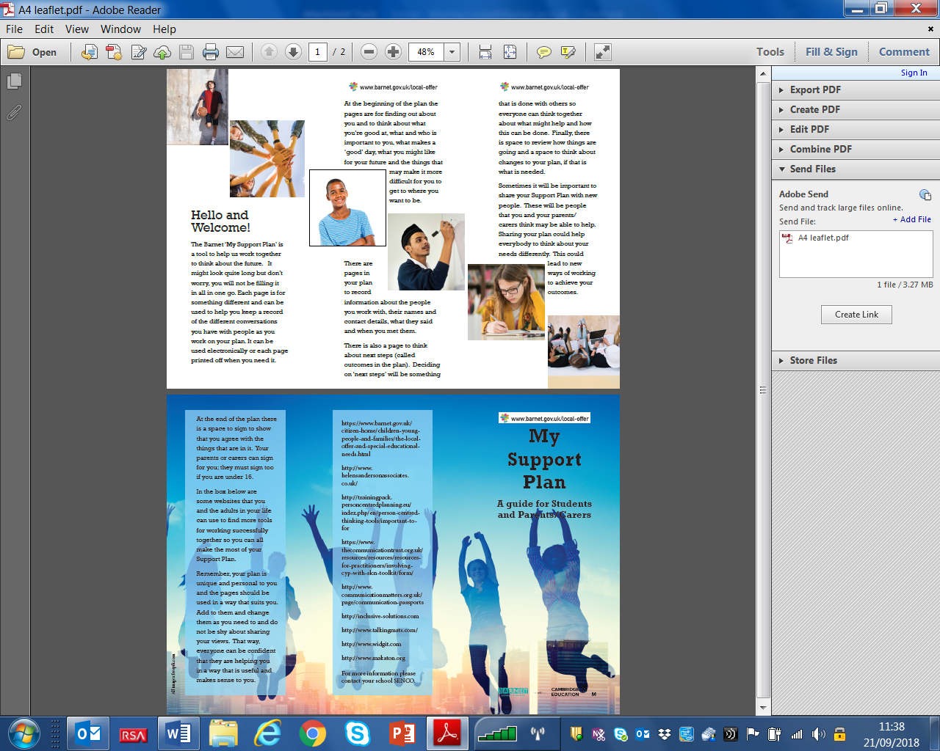

# Appendix 2 – Useful Links

Barnet Local Offer: <https://www.barnet.gov.uk/citizen-home/children-young-people-and-families/the-local-offer-and-special-educational-needs.html>

Toolkit for SENCOs: <https://www.barnetlocaloffer.org.uk/blog_articles/1776-new-toolkit-for-sencos>

Helen Sanderson Associates (useful person-centred planning tools): <http://helensandersonassociates.co.uk/>

The Communication Trust: <https://www.thecommunicationtrust.org.uk/resources/resources/resources-for-practitioners/involving-children-and-young-people-with-slcn-a-brief-guide/>

Communication Matters: <https://www.communicationmatters.org.uk/page/communication-passports>

Inclusive Solutions (Person centred planning tools): <https://inclusive-solutions.com/>

Talking Mats: <https://www.talkingmats.com/>

Widget: <https://www.widgit.com/>

Makaton: <https://www.makaton.org/>

# Appendix 3 – Circle of Support template

# 

# Completed Circle of Support Example

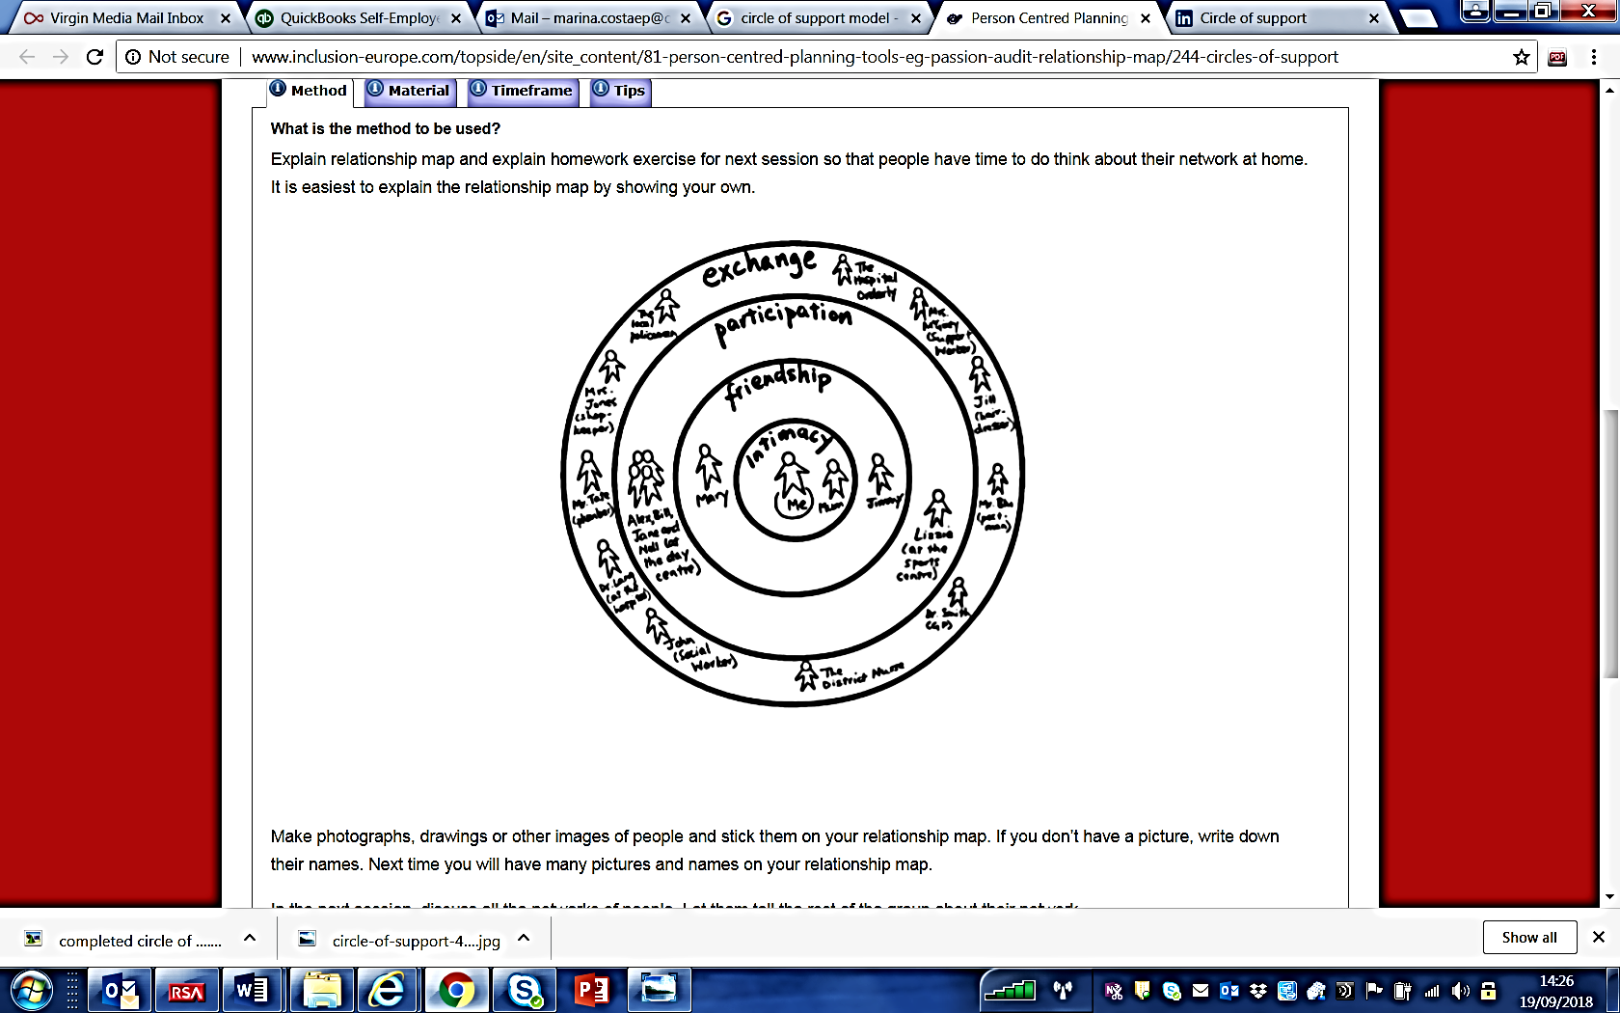

# Appendix 4 – Summary of Review and Next Steps

## This page can be used during the review meeting to prompt discussion. Reproduce this page, as needed. Don’t forget to make a note of the date.

## 

# Next Steps

Using the information from the review, go back to My Outcomes and Review and discuss and agree outcomes for the next cycle of assess, plan, do, review. You can continue with this plan or start a new one if you prefer. Make sure that you number each plan if there is more than one.

## Remember the Golden Thread:

**Provision**

**Outcomes**

**Needs**

**Hopes and Aspirations**

# Appendix 5 – Outcomes Builder – Where do I start?

1. Start with the broad area of need for the outcome, e.g. Communication & Interaction

XX will develop communication skills

1. Think about the **specific** areas of communication skills that you want to work on

XX will develop his/her ability to participate in a conversation

1. Add a **measure** of progress

XX will develop his/her ability to participate in a conversation so that they can maintain a conversation with a peer for 1 minute

1. Is this **achievable** and realistic for the pupil?
2. Add a **time period** for when this should be achieved

XX will develop his/her ability to participate in a conversation so that they can maintain a conversation with a peer for 1 minute by the end of the Autumn term

See also Setting Outcomes section on the Barnet Local Offer: <https://5f2fe3253cd1dfa0d089-bf8b2cdb6a1dc2999fecbc372702016c.ssl.cf3.rackcdn.com/uploads/ckeditor/attachments/3573/Section_05_Setting_Outcomes_Guidance.pdf>

# Appendix 6 – Chronology of My Support Plan & Reviews

## You can use this table to keep track of annual My Support Plan Meetings and Reviews completed if you find this useful.

|  |  |  |  |
| --- | --- | --- | --- |
| **Number of Plan/Review** | **Date** | **Involved/attended** | **Signature or Parent/Young Person and Lead Practitioner** |
|  | Click or tap to enter a date. |  |  |
|  | Click or tap to enter a date. |  |  |
|  | Click or tap to enter a date. |  |  |
|  | Click or tap to enter a date. |  |  |
|  | Click or tap to enter a date. |  |  |
|  | Click or tap to enter a date. |  |  |
|  | Click or tap to enter a date. |  |  |
|  | Click or tap to enter a date. |  |  |
|  | Click or tap to enter a date. |  |  |