As a starting point you may want to consider where the child is at with regards to involvement and well being
The Involvement Scale: The scale goes from 1 (uninvolved) to 5 (totally absorbed)
Level | Description
Level 1 | Uninvolved Completely uninvolved. Sometimes young children walk away, stare into space or do not interact with the people or play materials
Level 2 | Only involved for brief periods. They may be wandering around aimlessly. Sometimes they do things that do not challenge them, so they are not learning anything new
Level 3 | Involved some of the time but what they are doing is not very important to them. If you ask them to do something different, they will easily switch to a different activity
Level 4 | Involved in something they have chosen, which is important to them. They are not easily distracted yet there are moments when they need a parent’s or worker’s interest to help keep them involved. (A child can be involved by watching or thinking intently - the eyes show brightness, and the body language demonstrates their involvement)
Level 5 | Totally absorbed Deeply involved. They know what they want or need to do. They can choose, continue to be absorbed for long periods and show most of the signs of involvement

The Well Being Scale: The scale goes from 1 (low wellbeing) to 5 (high level of wellbeing)
 | Descriptions
Level 1 | Well-being is very low. None of the signs of well-being are shown. No interest is shown in interacting with others or in playing. Eyes are dull. Little energy is shown. A child might look withdrawn and becomes anxious quite easily.
Level 2 | About half of the time, signs of emotional discomfort might be displayed. There is a lack of trust. A child may be watchful or cling to one person. A child whose well-being is low cannot sustain enjoyment, worries about what other children have and may enjoy hurting others.
Level 3 | Expresses their feelings most of the time. Occasionally, a child may get anxious, seek reassurance or seem uncertain. They may show distress at transition times, for example, moving into group time from free play time.
Level 4 | Generally able to communicate and express their feelings. A child whose well-being is high feels comfortable enough to ask for what they want and to choose what they want to do confidently. They rarely show signs of discomfort.
Level 5 | An extremely high level of well-being and behaves like “a fish in water”. The nursery is “their place” and they radiate vitality, relaxed
(Adapted from Laevers 1997 p36-37 and AcE Project, 2001)
Questions to consider/ask when planning an observation
Communication:
How am I communicating?

How do I indicate choice? (verbally/non-verbally/gestures/eye gaze/vocalisations)

When do I seek to initiate communication or when do I simply respond to others?

How do I initiate?
Social Interaction (PSE):

How do I interact with others around me?

How do I interact with my peers? Am I aware of them? Do I react to them?

How do I respond to familiar/unfamiliar adults?

How do I initiate social interaction?
Play/ Cognition:
How am I showing interest in/engaging with play opportunities?

What are my favourite play activities?

How do I problem solve?

When is my play purposeful?

What is my level of concentration?

When is my play flexible?

How do I cope with interruptions?

When do I share my play experiences with others?

When do I play alongside my peers or chose another area to play?

Physical development:
How am I using my gross and fine motor skills? (Dressing/undressing/mobility/handling toys)
How do I move around?
What are my feeding and self care needs?
Regulating My Needs:
What do I do if I am overwhelmed or upset?

What do I do if I am frustrated?

Do I have sensory needs, sensitivities or sensory seeking behaviours e.g. visual, auditory, touch, body movements?
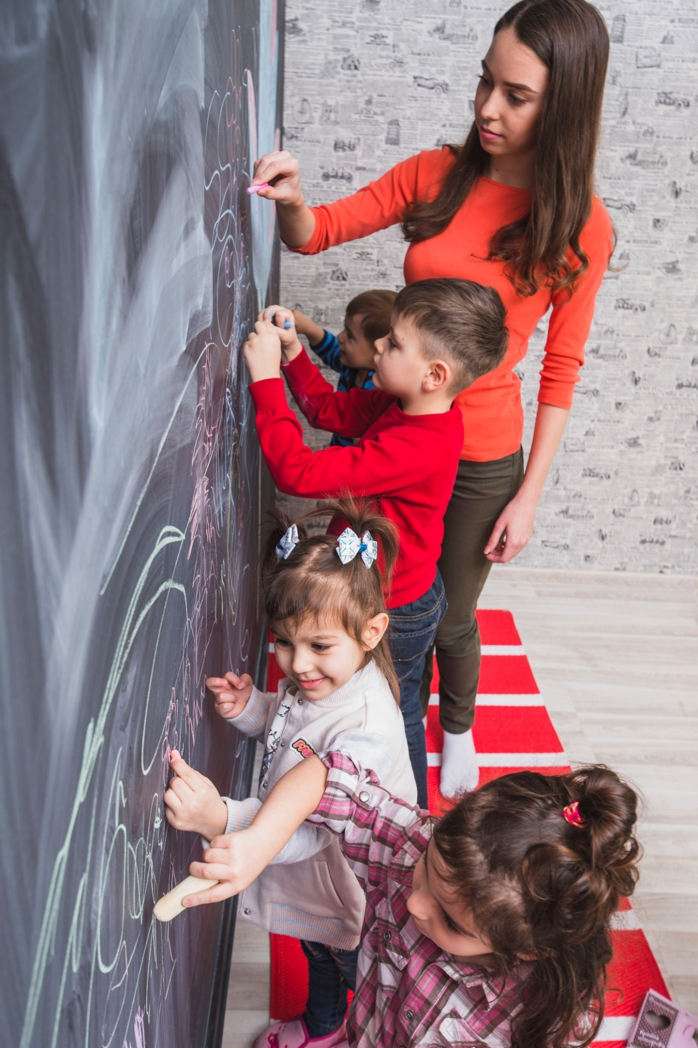

Identification of need

The Early Years

Image by Freepik.com

Foundation Years - Communication and Interaction
 | By 1 year old the child may need support for some of the following: | Occasionally  1-2 times per week | Sometimes  3 – 5 times per week | Most of the time
Communication and interaction | smiling, looking and moving in response to your interaction
 | vocalising back when talked to, making own sounds, especially to a familiar adult and when a smiling face is used
 | listening to nursery rhymes with enjoyment
 | showing excitement at the sound of approaching voices, footsteps and other sounds.
 | By 2 years old the child may need support for some of the following:
Understanding | understanding and following simple instructions in context, eg ‘come for snack’
 | pointing to simple body parts when asked
Speaking | spontaneously naming common objects which interest them, eg car, bird
 | copying expressions they hear a lot, eg ‘all gone!’ ‘oh dear!’
Listening & attention | enjoying nursery rhymes and trying to join in with actions or sounds by copying
Interaction | being aware of other people’s feelings – for example to look concerned if hears crying or to look excited if hears a familiar voice
 | taking turns in a simple ‘conversation’
 | pointing to draw attention to things of interest.
 | By 3 years old the child may need support for some of the following:
Understanding | understanding simple instructions involving a choice of 2 people or objects, eg  ‘Give the car to James’  ‘Give the ball to Annie’
Speaking | joining 2/3 words together with meaning, eg  ‘Daddy car’  ‘Mummy gone’
 | being understood by familiar adults
Listening & attention | recognising and joining in with songs and actions, eg ‘The wheels on the bus’
 | concentrating on an activity of their own choosing for a short period of time
Interaction | playing ball co-operatively with an adult (eg kick or roll back and forth)
 | starting interaction with and playing alongside other children
 | expressing emotions and seeking a reaction, for example crying at a minor injury and asking for help or comfort.
 | By 4 years old the child may need support for some of the following:
Understanding | understanding position words, ‘in’ ‘on’ ‘under’  eg ‘put Dolly under the chair’
 | answering ‘who’ ‘what’ ‘where’ questions about a story
Speaking | talking about ownership, eg  ‘My teddy’ ‘Jack’s car’
 | using simple pronouns correctly, eg ‘I’ ‘me’ ‘you’
 | being understood by unfamiliar adults
 | talking about what s/he has been doing
Listening & attention | stopping and listening to an adult who has called their name and then refocus on their original activity
 | attending to an adult’s choice of activity for a short period of time
Interaction | including another child in their play sequence and talking to them as they do so, eg give a child a cup to drink from
 | seeking out others to share experiences, eg by saying ‘watch me’.
 | By 5years old the child may need support for some of the following:
Understanding | identifying an object from a description of its use, eg  ‘What do we use to cut things with?’
Speaking | retelling a simple past event or familiar story in the correct order, eg  Went down the slide and hurt finger
Listening & attention | remaining focussed during a short story/singing session in a large group
Interaction | expressing wishes and needs clearly and understanding when these are not immediately met
 | regularly using adults as sources of knowledge, comfort and shared activities
 | enjoying and joining in with shared play.

Foundation Years – Cognition and Learning
 | By 2 years old the child may need support for some of the following: | Occasionally  1-2 times per week | Sometimes  3 – 5 times per week | Most of the time
Copying / Pretend | imitating some everyday routines eg using a mobile phone, washing the car
Problem solving | Retrieving out of reach toys or other objects
Memory | remembering where familiar things are kept and how to find them
Concepts | building 3 blocks, scribbling on paper
Social | bringing a book or toy to share with an adult
Curiosity | filling and emptying containers.
 | By 3 years old the child may need support for some of the following:
Copying / Pretend | developing simple sustained play with dolly/teddy eg eating, drinking, sleeping
Problem solving | operating a mechanical toy, for example turning the knob on a wind up toy, pushing a button to open a flap
Memory | spontaneously singing some of the words and actions of a familiar rhyme
Concepts | matching pictures of familiar objects in play
 | painting or drawing horizontal lines and circles in imitation
Social | watching others play and joining in briefly
 | following the daily routine
Curiosity | participating in a range of creative activities eg exploring and experimenting with sensory materials, musical instruments, using paint etc
 | By 4 years old the child may need support for some of the following:
Copying / pretend | joining in make-believe play with other children
Problem solving | suggesting using sticky tape to mend a torn book, choosing an appropriate tool to dig in the sand
Memory | recalling 2 or 3 pictures/objects hidden in a memory game
Concepts | understanding size difference, eg selecting the bigger or smaller object or picture when asked, putting features on a drawn face
Social | demonstrating concern towards others who are upset, for example offering a favourite toy, patting arm or back
Curiosity | showing a curiosity about how things work, how things feel, how things sound etc.
 | By 5 years old the child may need support for some of the following:
Copying / pretend | imitating adult roles, eg dressing up for dramatic play
Problem solving | choosing appropriate resources when making things
Memory | retelling or demonstrating something that happened in a familiar story
Concepts | sorting objects into categories eg all the animals, all the cars
 | drawing a simple human face (head and facial features)
Social | taking turns with other children in a child initiated activity
Curiosity | wanting to know how things work eg taking things apart, collecting things, asking questions.

Foundation Years – Social, Emotional and Mental Health
 | By 2 years old the child may need support for some of the following: | Occasionally  1-2 times per week | Sometimes  3 – 5 times per week | Most of the time
Making relationships | giving a positive response to a familiar adult, eg turning, looking and smiling when spoken to
 | engaging in social interaction, eg bringing toys to a familiar adult to show and share
Self confidence and self awareness | taking pleasure in exploring objects
 | indicating his/her own needs, eg banging or bringing a drinks cup to an adult to indicate they would like a drink
Managing feelings & responses | using their key person for ‘emotional refuelling’, eg happy to explore activities but looks for key person for reassurance.
 | By 3 years old the child may need support for some of the following:
Making relationships | sharing/turn taking with an adult in a simple activity that they enjoy, eg rolling or kicking a ball back and forth
 | giving a positive response to a familiar adult
Self confidence and self awareness | separating from main carer with support of their key person (alternatively may show no sense of care in separating from main carer)
 | showing interest in the play of other children alongside them whilst sustaining their own, eg watching with interest what other children are doing in the water play whilst continuing their own exploration
Managing feelings & responses | cooperating with age-appropriate familiar expectations in relation to the routines of the setting, eg sitting for snack
 | sitting in a small group (3-4 children) with a familiar adult for more than 3 minutes doing an activity which interests and excites them, eg songs and rhymes.
 | By 4 years old the child may need support for some of the following:
Making relationships | engaging in positive interactions with other children in a structured situation, eg talking to other children whilst playing and joining in a group activity
Self confidence and self awareness | responding positively to a variety of adults, eg feeling confident to approach any adult in the setting for help
 | spending time in groups with other children but engaged in own play, eg is able to complete their task, i.e. junk modelling whilst being alongside others
Managing feelings & responses | understanding that some things are theirs, some are shared and some belong to other people
 | making predictable responses in a range of situations, eg helping to put toys away and get ready for group time
 | consistently responding positively to and coping with different events, social situations and changes of routines in the setting
 | expressing their own feelings and doing so in an appropriate way.
 | By 5 years old the child may need support for some of the following:
Making relationships | engaging in and sustaining positive interactions with other children
 | initiating and sustaining conversations with adults and children
Self confidence and self awareness | receiving praise and taking a pride in him/herself
Managing feelings & responses | staying on task to complete an age-appropriate adult initiated activity
 | managing their emotions if their needs are not met quickly
 | demonstrating concern towards other children, eg to comfort a child in distress
 | understanding that his/her own actions affect others
 | responding appropriately to simple instructions
 | understanding the needs of others and usually being able to share and take turns without adult intervention.

Foundation Years – Sensory and Physical needs - Hearing
 | A child with a hearing loss may: | Occasionally  1-2 times per week | Sometimes  3 – 5 times per week | Most of the time
The child with a hearing need may: | find difficulty in expressing him/herself clearly
 | appear loud, raising his/her voice in conversation
 | experience difficulty when activities involve listening and following instructions eg appears to ignore, confuses the direction of sound, mishears
 | often ask for clarification or repetition particularly in noisy environments or where the speaker cannot be seen
 | be more physical and use less language than peers in play activities
 | find it difficult to sustain concentration and become tired easily.
The child may need support for some of the following | listening in a small group or the whole class
 | articulating words clearly
 | making him/herself understood by an adult (this may lead to frustration or withdrawn behaviour)
 | aspects of learning and development related to language/verbal skills, eg to expand vocabulary
 | developing age-appropriate language structures
 | to be confident in tackling new activities
 | initiating conversations with teachers or peers
 | following whole class introductions and discussions
 | sustaining concentration in a small group or the whole class
 | managing anxiety and/or frustration
 | establishing and maintaining appropriate peer relationships
 | building self-esteem.

Foundation Years – Sensory and Physical needs - Hearing
 | A child with a hearing loss may: | Occasionally  1-2 times per week | Sometimes  3 – 5 times per week | Most of the time
The child with a hearing need may: | find difficulty in expressing him/herself clearly
 | appear dreamy and distracted
 | appear loud, raising his/her voice in conversation
 | startle easily
 | use gesture more than his/her peers
 | not appear to understand common phrases and may have a limited vocabulary use
 | be more physical when expressing their needs and wants
 | find it difficult to sustain concentration especially when there is background noise.
The child may need support for some of the following | listening in a range of situations
 | following instructions; the child may be noticeably more able to do this in a quiet area
 | joining in activities in a small group
 | following and responding in an age-appropriate conversation, especially where visual clues are not available
 | making him/herself understood by others; his/her expressive language may be unclear
 | sustaining attention during whole group activities, e.g. listening to a story; the child may be noticeably more attentive and able to maintain concentration in a quiet area
 | developing and using age-appropriate language; the child may use gesture to compensate
 | accessing TV/DVD/music at normal sound levels
 | enjoying songs and rhymes and join in by copying
 | to start interaction with and play alongside other children of a similar age
 | sustaining age-appropriate positive interactions with other children
 | developing pretend play activities
 | managing anxiety and/or frustration.

Foundation Years – Sensory and Physical needs - Visual
 | A child with a visual need may: | Occasionally  1-2 times per week | Sometimes  3 – 5 times per week | Most of the time
The child with a visual need may: | tilt his or her head and/or use his/her body in a different way to other children to maximise vision
 | bring eyes close to a toy, or a toy close to eyes
 | blink frequently
 | touch, rub or cover eyes
 | appear sensitive to light or glare
 | have eye pain, headache, dizziness, or nausea, especially after periods of looking closely at something
 | move eyes towards the nose when looking at very near objects
 | find it difficult to track the movement of something across the field of vision, eg a ball rolling from left to right
 | find scanning difficult, eg searching for a toy in a room
 | bump into things as they move around
 | not respond to a non-verbal gesture.
The child may need support for some of the following | By 2 years the child may need support for at least one of the following:
 | to spoon food or pick up a cup
 | playing with a ball
 | pointing to pictures.
 | By 3 years the child may need support for at least one of the following:
 | drawing features on a pre-drawn face
 | catching a ball with both hands
 | kicking a moving ball
 | recognising detail in a picture.
 | By 4 years the child may need support for at least one of the following:
 | for age-appropriate activities that involve hand-eye co-ordination, eg placing small pegs in a board, threading beads
 | cutting with scissors
 | completing inset puzzles
 | copying simple shapes, eg a cross
 | finding small details in pictures, eg Where’s Wally?
 | joining in with outdoor play and physical activities.
 | By 5 years the child may need support for at least one of the following:
 | for age-appropriate activities that involve hand-eye co-ordination, eg threading a large needle
 | copying a pattern, eg a sequence of bricks
 | copying his/her own name
 | recognising letters and numbers even when printed boldly
 | drawing a recognisable human figure with details like hair/buttons
 | using outdoor equipment, eg playing games with balls, hoops.

Foundation Years – Multisensory needs
 | A child with a deaf blindness/multi-sensory need may: | Occasionally  1-2 times per week | Sometimes  3 – 5 times per week | Most of the time
The child with a multi-sensory need may: | make idiosyncratic responses to auditory and/or visual stimuli
 | avoid touch or make a startled response to touch (tactile defensiveness or reluctance)
 | have problems with eye contact and interaction
 | find it difficult to fix and track an object, eg a ball rolling across the floor
 | be delayed in developing skills and in achieving developmental milestones, eg walking
 | tilt his or her head and/or use his/her body in a different way to other children to maximise vision and hearing
 | have difficulty in making sense of the world because of fragmentary information received through the senses
 | appear withdrawn or isolated, eg may spend and unusual amount of time asleep
 | display unusually passive behaviour
 | display repetitive or challenging behaviour; this is likely to be a result of sensory overload
 | use smell, taste, movement and touch to gain information or to support mobility
 | be unable to find things or people when they have moved
 | have difficulty caused by changes in light levels, glare and reflection
 | have difficulty when attending unfamiliar places
 | appear clumsy – bumping into doorways, tripping over objects on the floor.

Foundation Years – Sensory and Physical needs - Physical
The child may need support for some of the following | By 2 years the child may need support for at least one of the following: | Occasionally  1-2 times per week | Sometimes  3 – 5 times per week | Most of the time
 | walking holding an adult’s hand
 | trying to feed him/herself with a spoon
 | holding a lidded beaker in 2 hands and drinking
 | holding a crayon and use different strokes to make a scribble
 | building a tower of 2 blocks
 | taking off easily removed clothes, eg socks
 | using a finger thumb pincer grasp, eg picking up a raisin.
 | By 3 years the child may need support for at least one of the following:
 | walking confidently, avoiding obstacles
 | helping with dressing and hygiene routines
 | walking up and downstairs, holding on, 2 feet to each step
 | kicking a large ball
 | using hands to screw and unscrew simple toys and lids, turn doorknobs
 | holding a pencil between thumb and two fingers and make a circular scribble
 | squatting steadily to rest or play with objects on the ground and rising to feet without using hands.
 | By 4 years the child may need support for at least one of the following:
 | building a tower of 6 – 9 blocks
 | climbing on nursery play equipment
 | walking downstairs, two feet to a step
 | taking off an unzipped coat
 | undoing Velcro fasteners
 | trying to use scissors to make snips in paper
 | manipulating simple construction toys, eg Duplo.
 | By 5 years the child may need support for at least one of the following:
 | pedalling a trike
 | running confidently
 | washing and drying his/her hands
 | catching a large ball
 | jumping forward on two feet
 | communicating the need to use the toilet
 | holding a pencil between thumb and forefingers and drawing different shapes.

