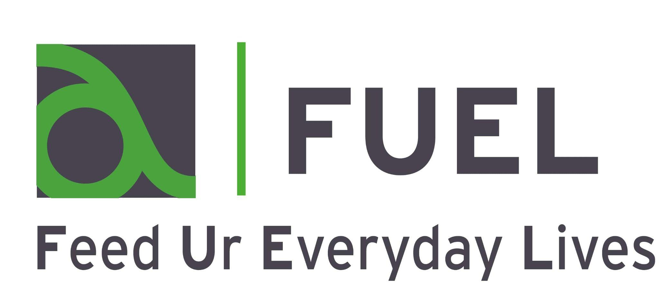

FUEL 2022 FAQ’s
What is FUEL?
FUEL is the local name for the Holiday Activity and Food (HAF) programme funded by the Department of Education for children receiving benefits-related Free School Meals within Kingston and Richmond.

How do I apply to be a FUEL provider?
All prospective providers will need to complete an online application which can be accessed following this link(Opens in a new window).

Is there a paper application or do you have to bid through the website?
The application is completed online. We will be uploading a printable version also. You can use the PDF version to prepare your answers, then copy and paste them into the online application portal.

How do we know which children and young people are eligible for FUEL?
The FUEL programme is for children who live in or go to school in the London Boroughs of Kingston or Richmond and are in reception to year 11 who qualify for benefits-related Free School Meals (FSM). Any 4 year olds on the programme must be in reception, not nursery.
Not all the children in reception to year 2 who receive Infant Free School Meals are eligible for HAF. You will need to check those children qualify for benefits-related FSM. More information is here: Apply for free school meals - GOV.UK (www.gov.uk)

Do children require hot meals as part of the programme?
Yes. If you are doing offsite trips then it is acceptable to take packed lunches.

Can we offer paid for places alongside the FUEL places on our holiday club?
Yes. However, the FUEL funding can only be used for FSM eligible children. You can use your other funding sources for children who are not eligible for FUEL. This might include offering paid places.

Will the staff delivering the HAF programme all need satisfactory enhanced DBS checks?
Yes. All of your staff who have unsupervised access to children must have an enhanced DBS check including a check of the barred lists. More information on DBS checks are here: DBS checks: guidance for employers - GOV.UK (www.gov.uk)
DBS Exception example: A guest speaker or presenter visits a holiday activities and food programme club to deliver a talk on nature. The guest is escorted by staff at the club (who are DBS checked) while on the premises and is not left unsupervised with children at any time. In these circumstances, we would not expect a DBS check to be carried out.

How will you award places?
Applications will be screened as soon as possible after the closing date, and successful applicants will be notified shortly afterwards. A selection criteria is available in the guidance document, and we will be making sure provision matches areas of need within the boroughs.

Can we just offer support for children remotely?
No. We know that the HAF programme offers a wide range of support for families and goes well beyond the delivery of food and activities: it’s a point of contact for children and families during holiday periods that can be vital for them in accessing support and services and that holiday provision is most effective when it is delivered face to face.

What if there’s another lockdown?
The government does not anticipate any further lockdowns at present. In the unlikely event there is a full lockdown, we would expect you to provide:
- High quality and seasonal recipe boxes or food parcels that provide healthy meals
- Activity packs
- Access to online activities and support

Would we be responsible for promoting directly to families for the holiday clubs or would this be done by the council?
Both - we will be doing a borough-wide promotion, and targeting eligible children via schools, but we also expect providers to advertise their FUEL programme themselves and reach out to families they may already be in contact with.

Can we use the FUEL money to buy families vouchers for things like food or utilities?
No. You cannot use FUEL funding to provide families with vouchers. If you have an alternative source of funding you can use this for anything else you’d like to provide to families.

When will providers be paid?
You will receive half the costs upfront, and the other half after you submit satisfactory monitoring data in May 2022.

Will there be support available from the FUEL team?
Yes. We will offer email support and regular online meetings, both before, during and after the programme. We will also carry out visits when the programme is delivered.

How many applications should I complete if I plan to run across multiple sites?
Organisations will be able to use one grant application form to apply for multiple locations. For separate projects, please complete a separate application.

What can the grant fund?
Grants can fund:

The cost of the child's place (covering staff, premises, resource, and business costs). This amount should not be any more than your usual fees and charges expected from fee paying parents;
The cost of providing nutritious meals;
Administration costs associated with marketing and booking places for eligible children, parental liaison and engagement;
Your costs should be displayed as an amount per child per day.

Does the project or scheme need to be in a particular area?
Children who are eligible to receive benefits-related free school meals live in all areas of Kingston and Richmond, but distribution across the boroughs is not equal, with some districts having far more FSM eligible children than others. Furthermore, we know that these same areas often lack sufficient holiday activity opportunities. Therefore, resources will be focused on priority areas as we deem appropriate.

Does the project have to run for a minimum amount of time?
Achieving for Children are required to have a programme of FUEL activities that offer a minimum of 4 hours per day and 4 days per week for eligible children/families. AfC will award grants to organisations on the number of places needed in a specific geographic area. It will be for the organisation to ensure that the minimum offer is available to children and families who attend, most organisations will be able to exceed the minimum offer. We acknowledge that there may be some projects that might deliver one-off or bespoke FUEL activities that contribute to the overall FUEL programme.

Do the activities provided have to focus on anything in particular?
The planned activities should be designed to promote healthy eating and an active lifestyle. In particular projects and clubs/schemes should aim to incorporate a minimum of 60 minutes physical activity within every session.
Planned activities should be enriching for children; increasing their knowledge and understanding of healthy choices and the skills to make such choices.
Clubs/schemes and projects should show how they encourage children to be safe and not socially isolated.

What reporting, and management information will you need from me if I am successful?
Organisations will be required to complete and submit monitoring twice before the programme, and evaluation forms on completion of the holiday period. Information will include (but is not limited to):
Numbers of eligible children attending activities (weekly)
Outcomes of activities
Participants’ feedback
Parental feedback
Financial reporting will include:
A breakdown of expenditure
A breakdown of any unspent grant.
Any funding issued by Achieving for Children to organisations will be supported by a Service Level Agreement setting out our expectations of organisations in accepting grant funding.
Any unspent grant funding will have to be returned to Achieving for children within 30 days of the end of the grant period.
If Achieving for children have any grounds for suspecting financial irregularity in the use of any grant paid under this Grant Agreement, an investigation will take place. For these purposes ‘financial irregularity’ includes fraud or other impropriety, mismanagement, and the use of grant for purposes other than those for which it was provided.

Where do I go if I have questions or need some advice? Who do I ask?
Please email FUEL@achievingforchildren.org.uk

