The Boxall Profile

- Relationship of the person completing the questionnaire to the child?
- How many terms have they known the child?
- Quality of their relationship
(Scaled 1-7
1 being very negative
4 being neither positive or negative
7 being very positive
or prefer not to say
- SEMH/wellbeing interventions the child has accessed:

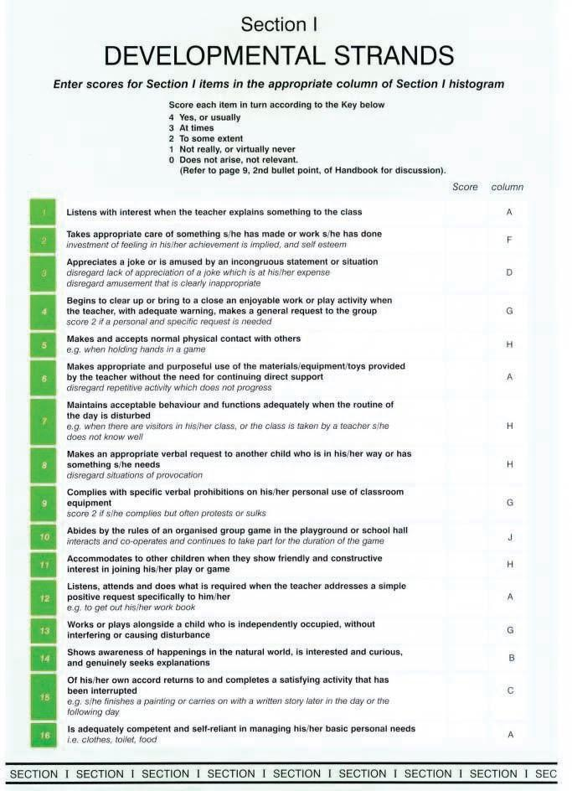
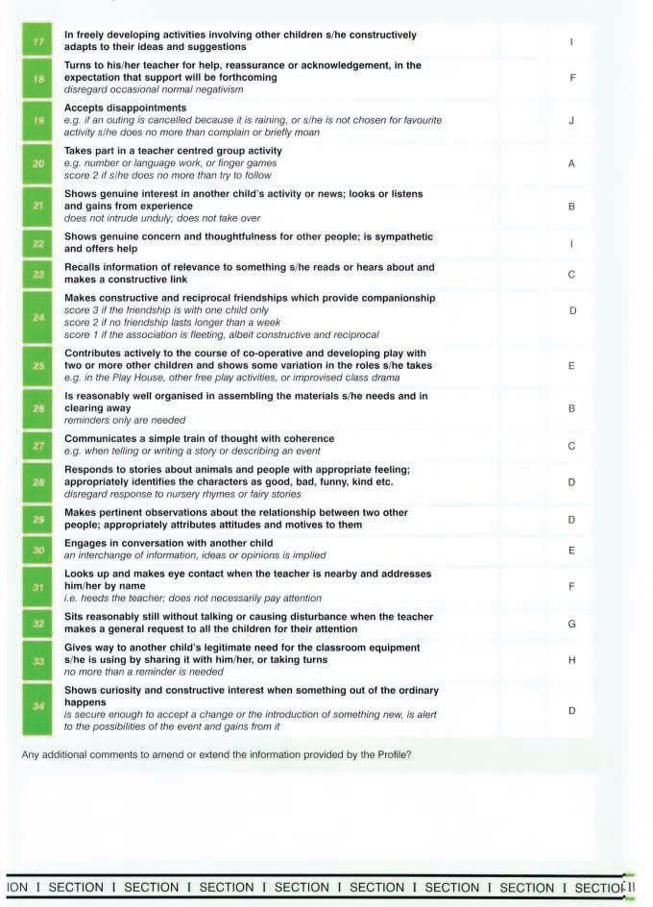
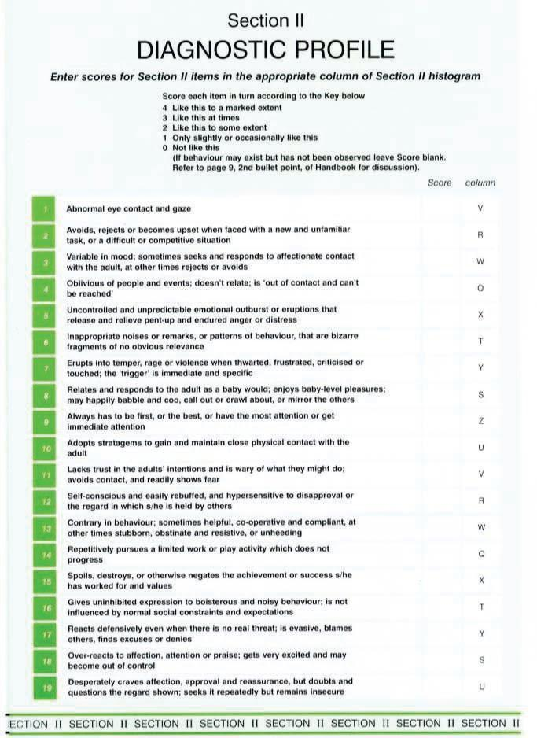
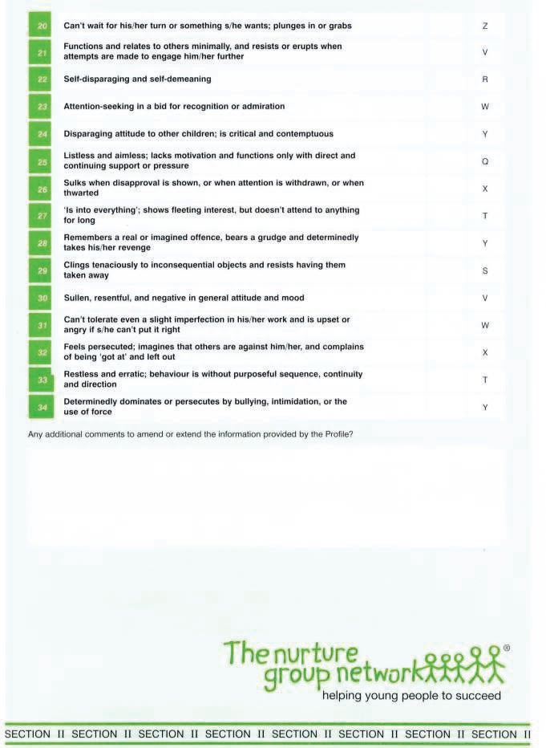

Pupil Name:
Boxall questionnaire completed by (print name):
Job Title:
How long have you known this pupil (months/years):

