Deaf Awareness Week 1st May-7th 2023
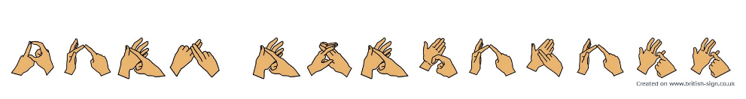
What is Deaf Awareness week and why do we celebrate it?
Each year in May we celebrate Deaf Awareness week to remind everyone about the contribution and needs of D/deaf children and adults in our communities. There are 12million adults in the UK who are deaf or have some hearing loss. (RNID website April 2023). There are estimated to be around 50,000 deaf children and young people in the UK.
Most deaf children attend mainstream schools in the UK. It is important that staff at these settings have the strategies to be deaf friendly.
Please look at:
- top tips communicating with deaf children and young people. NDCS resource Talking to deaf children flyer 2019
- Myth busters about deafness and deaf people Myth busting true or false statements 2023
- Fingerspelling chart fingerspelling-poster
- RNID Deaf awareness - RNID
- RAD Home Page - Royal Association for Deaf people (royaldeaf.org.uk)

