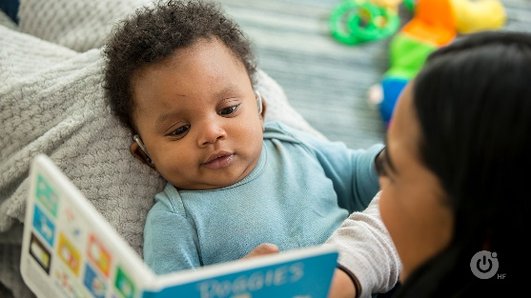
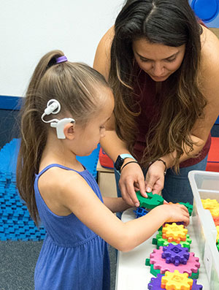
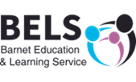
Deaf Awareness week resource:

Myth Busting True or false:
- All deaf people can lip-read False!
Not all people can lip-read. Lip-reading is hard work. It takes a lot of effort and concentration and can be really tiring. Not all lip-patterns are recognisable. Try looking in the mirror and saying ‘pat’ ‘mat’ ‘bat’ without using your voice-can you tell the difference? Even people who say they are good at lip-reading can only understand about 30% of what is being said-the rest is guesswork.
- Deaf people cannot enjoy music False!
Lots of deaf people love music. Some deaf people can hear music, others might not be able to hear music very well but can enjoy the vibrations. There’s lots of technology that can help deaf people enjoy music.
- Sign language is the same everywhere False!
Just as there are thousands of different spoken languages around the world, there are hundreds of different sign languages. Even English speaking countries have their own sign languages- Britain has British Sign Language (BSL), the USA has American Sign Language (ASL) and Australia has Australian Sign Language (Auslan).
- Deaf People can’t use the telephone False!
Lots of deaf people use the telephone, some can hear well enough to use a standard telephone-others use technology like amplified phones. Even if a deaf person cannot hear on the phone they can text, use Face Time, Skype and use services like text relay.
- Deaf People can hear everything with their hearing aids and cochlear implants False!
Hearing aids can help focus sounds and make them louder, cochlear implants carry sound directly to the brain. But this does not mean a deaf person hears in the same way or as well as a hearing person.

