Cygnet Parent / Carer Autism Training
A comprehensive training and support program for parents/ carers of children aged 6-19, with a diagnosis of autism.
This course is available free of charge to families living in Barnet.
Cygnet is a 6-week training course covering topics including:
- An overview of autism
- Communication
- Sensory needs
- Understanding behaviour
This course also gives parents/carers an opportunity to meet to meet each other and share their experiences.
Where : Online | When: Wednesday morning 10.00 - 11.30am  September 7th, September 14th, September 21st, September 28th, October 5th, and October 12th
The course is free, but it is essential that parents/carers register.
Please use this link:
CYGNETS registration form Autumn 1 (Sept/Oct) mornings 2022
Or scan the QR code: 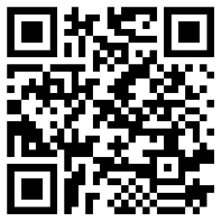
For any enquiries please email : autism.team@barnet.gov.uk with ‘Cygnets’ mentioned in the subject line.

