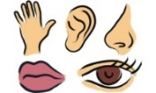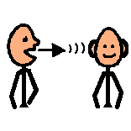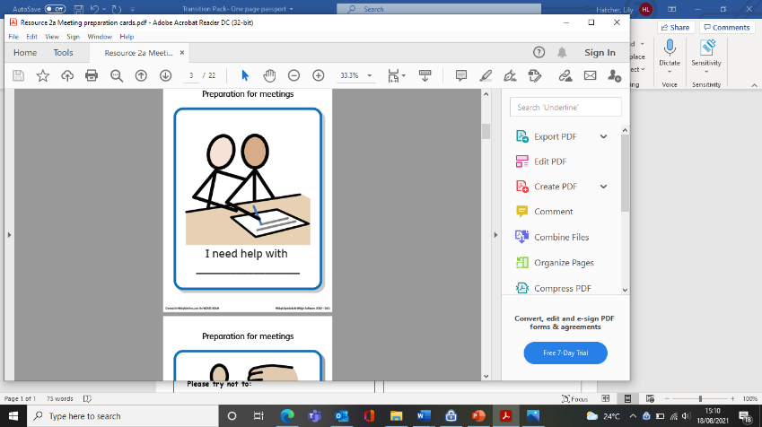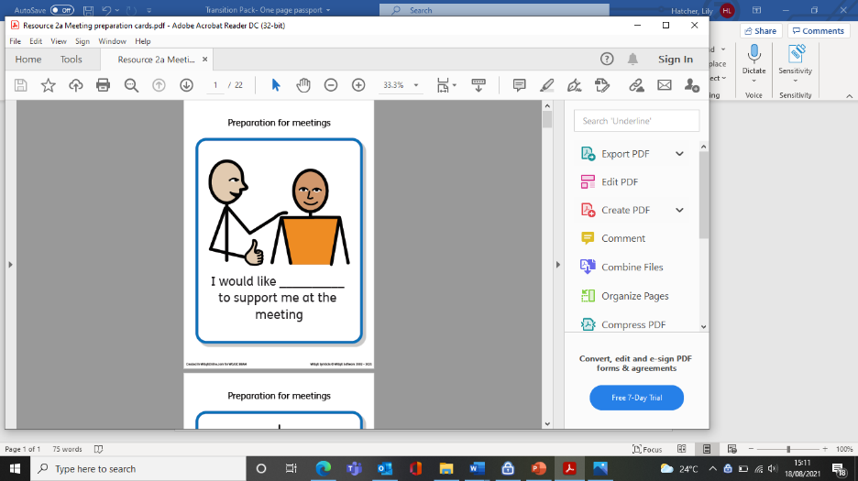[](http://www.bing.com/images/search?q=Calm+Face+Emoji&view=detailv2&&id=05434F67B10E26313908084295B4D42DE99C7AE6&selectedIndex=0&ccid=5LpomOaZ&simid=608026881689191272&thid=OIP.Me4ba6898e699e2789013adb4de14e9f2o0)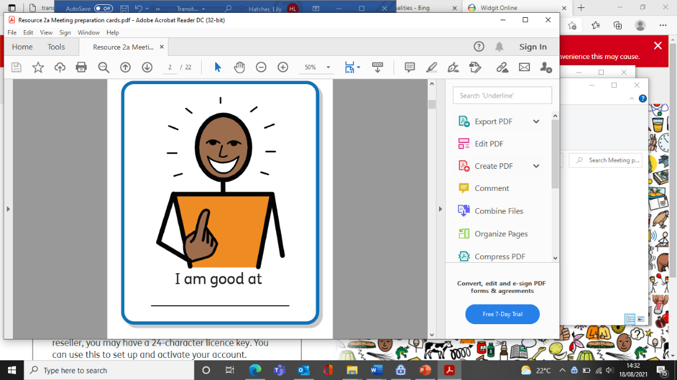

**Things that worry me:**

_____________________________________________________________________________________________________________________

**My favourite things:**

________________________________________________________________________________________________________________________

**My Name is:** _______________________

**My Form Tutor is:** __________________

**Who can help if I have a problem:** ___________________

photo

**To help me learn:**

Please do…

**My emotional wellbeing:**

(How you can help me stay calm and happy)

**Please do:**

**Please try not to:**

**When I am learning:**

Please don’t…

**My sensory needs are:**

**How I like to communicate and visual supports that help me:**