**Widcombe Acorns Preschool**

**Local Offer**



Ofsted number: 133108

**Our mission statement:**

We aim to provide a caring, nurturing and safe environment where children can play, learn and grow happily and securely. Every child is unique, therefore we plan to encourage and enable individuals to progress at their own pace and reach their full potential. Of paramount importance is the development of the child’s personal, social and emotional skills. Self-confidence is encouraged in a sensitive, responsive, warm and loving environment. We work towards each child becoming a valued member of Acorns and of the wider community so that they develop a strong self-image and high self-esteem.

We respect parents and carers as the child’s first educator; we aim to make them a part of their child’s future learning, involved in all areas of Acorns.

In Acorns we aim to provide appropriate learning opportunities to all children who attend. We endeavour to identify any children who would benefit from additional support and seek the appropriate provision in order for the child to reach his or her full potential.

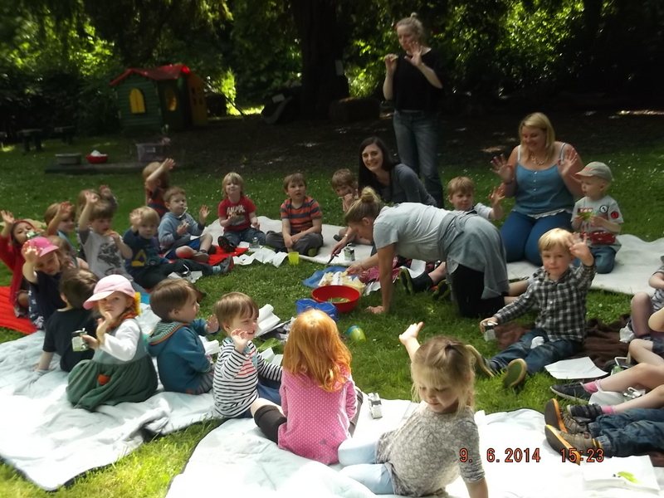

**Our enabling environment:**

Widcombe Acorns is a pre-school that operates in term time only. We accept children from 3 years old, or, if space, those who turn 3 within the first term.

* Inside environment – Widcombe Acorns has spacious permanent rooms within St Marks church. Our rooms are uncluttered, with neutral tone walls and curtained areas which house our resources.
* We have a large main room, a smaller ‘quiet’ room for registration, story times, and small group work, and a large home corner which is permanently set up with a castle den, dressing up clothes and home corner equipment. We have use of a large hall, side rooms and a large kitchen three full days and two half days per week.
* Outside environment – We have extensive gardens, with mature trees. In the garden we have a mud kitchen, climbing trees, a story telling stage and a large planting area for the children to grow their own food to harvest and cook in the summer term. We have an entrance suitable for wheelchair users and an accessible toilet. We have a varied outside environment with large grassy areas, trees, bushes and a hard standing. We aim to have a high staff ratio which gives us the opportunity to give further support to children where needed. We have rooms that can be adapted to accommodate many different and varied needs.
* We have proven experience of including children with a range of unique additional needs, for example\; children with a diagnosis of autistic spectrum disorder (ASD), children with Social, and emotional and mental health difficulties. These children did not just join us, they joined in with the Acorns experience as we worked in partnership with families and other specialists to support their needs and enable them to have positive learning experiences.

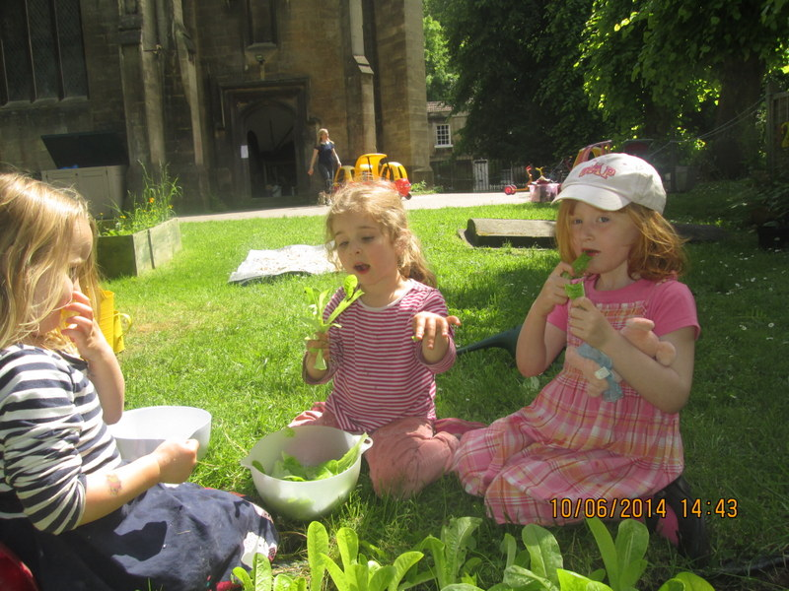

**Quotes from parents:**

**“You take great care to get to know each child as an individual, and you do this very quickly”**

**“Thanks for taking the time to get to know our son and for supporting him with his emotional development. Thanks in particular for finding time to support us as parents in that too.”**

**“I would like to thank all of the staff at Acorns who work so hard to make Acorns such a unique and wonderful place. You are all such lovely, highly skilled and talented, warm people that it has made my daughter thrive.”**

**“You have all been wonderful, my daughter loves coming to Acorns and loves her teachers dearly.”**

**“The more I learn about great EYFS practice on my PGCE the more I see how you exemplify it”**

**“The love, care and enthusiasm and Acorns ‘specialness’ is unique”**

**“You have enthusiasm, you encourage excitement and wonder in the children (even in me!). Creating a happy environment, doing a variety of activities and instilling fun in to learning and development, just keep doing what you do.”**

**And from Emma Puttock, an Occupational Therapist:**

I would just like to flag up a setting I was in yesterday: Widcombe Acorns. I think it is the most fantastic setting out of all those I have visited in recent months, so much so that I want to praise it out loud!  The creativity, nurturing, established patterns (like the use of the visual timetable and children’s photo / register board), sense of fun, calm expectation of children’s behaviour etc etc etc… are just second to none!  If any setting out there is in difficulty then I cannot recommend Widcombe Acorns highly enough as a setting that could be visited or shadowed.

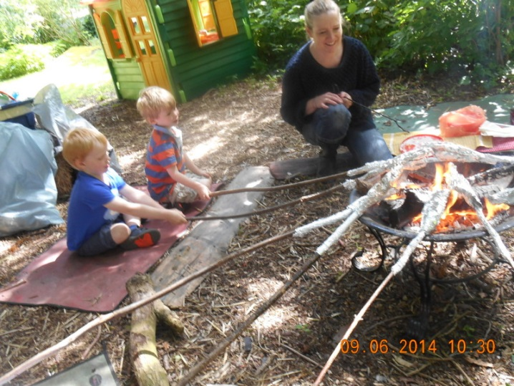

**Special Educational Needs and Disability Contact in Acorns:**

* Dena Moore is our named Special Educational needs and Disability coordinator (Senco) in Acorns, she has worked in Acorns for fourteen years, eight of those as Senco and six as the leader. Dena has experience of working with children with a range of different needs. Dena has a level 8 in Makaton signing, a level one in working with children using Theraplay principles, she has completed a portage course as well as attending many training days on different needs to support her role as Senco. She has also worked for Bath and North East Somerset Early Years Team for the past two years as an Area Senco Assistant, this role is on-going. Dena has helped to introduce Theraplay nurture groups and Sunshine Circles in to schools and pre-schools across Bath and North East Somerset.

**All staff have an inclusive approach and a ‘can do’ attitude to inclusion:**

* Dena is supported in Acorns by a very experienced team, most of whom have worked in Acorns for several years. We are lucky to have a very low turn-over of staff in Acorns, which provides a consistency of care toward our children.
* The team work extremely well together, with many different talents ensuring that there is a wide range of activities for the children to choose from throughout the session, all of the staff use Makaton signing daily.
* There is a consistency of care in Acorns throughout everything we do, children are always valued and respected by every member of the team.

**How we work – key person approach**

* In Acorns every child has a key person, this member of the team is there to support their children in settling in to Acorns, liaising with families and ensuring that we offer a smooth transition. Once the children are settled, the key person is there when needed, ensuring that their children are receiving the very best care

and opportunities to encourage and promote their well-being.

* The key person will ensure that any targets that have been set for your child are carried through in an appropriate manner, working directly with your child, within a small group, or on a one to one basis in a quiet area. All strategies are delivered in a fun and engaging manner, promoting success at all times. They will also monitor targets closely, and liaise regularly with Dena and with you.
* Dena, as the setting Senco supports all of the team to ensure that the children are receiving the highest possible care and attention, she will liaise with any outside specialists, and arrange and attend regular Team around the child meetings to ensure that the child is always put at the heart of our practice.

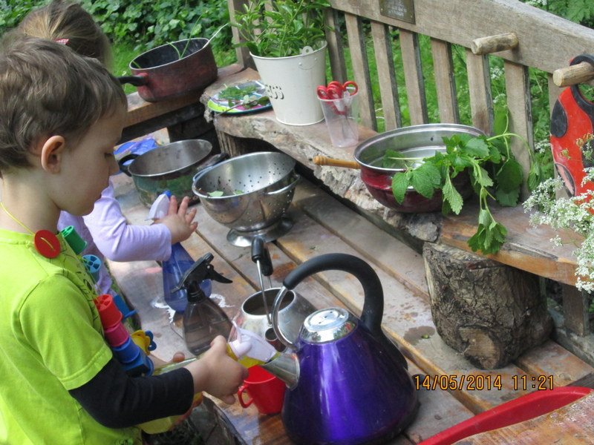

**Observations, assessments and summaries:**

* Throughout your child’s time in Widcombe Acorns the team will be observing your child, these observations are then collated in to a learning journal. The learning journal is a document that has photos, observations and anecdotes which make up a scrap book of your child’s time in Acorns. This gets sent home once per term for you to peruse at your leisure and add your own photos and comments from home.
* Three times per year we assess your child against the Early Years Foundation Stage goals, this is written up in a summary that covers all areas of learning. This enables us to see any gaps in the children learning to help us to identify any support that a child may need.

**SEN support:**

* Dena meets regularly with the staff team to discuss the children’s learning and development and to support the team in identifying any gaps in the children’s learning experiences. If any concerns are raised, by the staff team or by you, then Dena will start to observe the child, trying to put together a picture of their time in Acorns, and any additional needs they may have. Dena will then liaise with you to discuss how we can best support your child, and what the next steps may be.

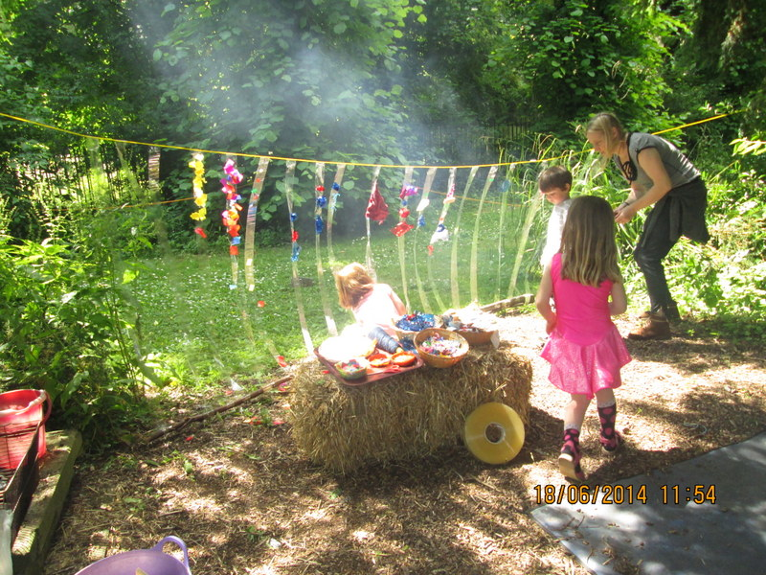

**SEN Support – and the graduated approach to supporting your child**

We feel that the more we work together the best support we can give to your child and your family.

* Once an additional need has been identified through observation and assessment we work with you to follow a graduated approach to supporting your child.
* This could include setting long term outcomes and strategies for you and the staff team to use, and setting short term targets. This would enable us to set small, achievable outcomes for your child over a six week period, to monitor the progress your child is making. We might put together a non-statutory plan called a ‘MY PLAN’ which helps us all focus on your child’s interests and needs and the best way to support them.
* We might request permission for a Local Authority Senco Advisory Teacher to come in and observe your child in the pre-school setting. The Area Senco will advise and support us with further strategies, information on reasonable adjustments to our practice and environment and will help us identify further staff training and development.
* We might request permission to complete an Early Help Assessment together, this enables you to collate all of your child’s history and needs in one place, and to tell your story, this can then be used when liaising with specialists or school staff to ensure that they have the information to give appropriate support to your child. This could support a request to a specialist, such as an Occupational Therapist, an Educational Psychologist, a Speech and Language Therapist or a Paediatrician.
* We might need to request extra support and inclusion funding from the Local Authority and we will work with you to do this. The Early Help Assessment will be very helpful in identifying and giving evidence of your child’s need to support an application of this request.
* Regular Team around the child meetings would be held to ensure that everyone is working together to gain the best outcomes for your child. Please be reassured that we will work with you at all times, and decisions would not be made without input from all involved.

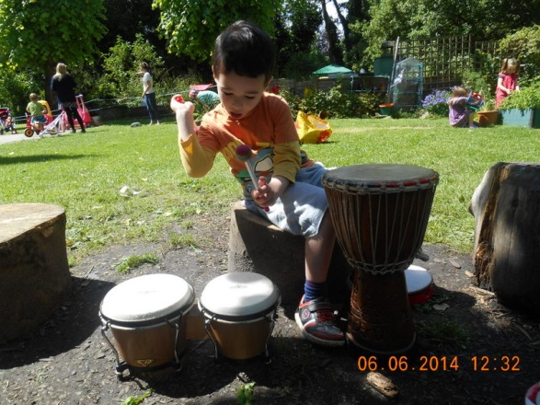

**Settling in:**

* We feel that the more information we have about your child before they start at the setting, the better we can ensure that we are offering appropriate support to ensure a smooth transition.
* In term six we hold a new parent’s evening, this is an informal evening where you will get the chance to meet the team, to have a tour and to discuss any concerns or information with us that may support a smooth transition in to Acorns.
* For the children we offer a Saturday taster session, this offers them a chance to play in the garden and with lots of the resources, to have a story and to start to familiarise themselves with Acorns.
* If you have any concerns or feel your child may need extra support, in any area, we welcome your information and guidance. Please feel free to call Dena anytime in term six to discuss this.
* We offer home visits for any children that may benefit by being more familiar with an adult before starting, and the staff team contact their key children’s parents by phone in the summer holidays to discuss any concerns.
* If your child attends another pre-school we may visit to meet your child and to chat to the staff team to see what they currently have in place to support your child. We continue to liaise with any shared settings throughout the year to support consistency of care.
* During new parent’s evening you will receive our ‘New Parent’s pack’ which gives you information on Acorns, including practical tips and hints, structure of the day and policies and procedures. In the pack you will find a page entitled ‘Child Profile’ this requests that you give us as much information as you possibly can about your child, we ask that any concerns, or information that may help us deliver a smooth transition is written in detail for us, we may contact you for further information if necessary.
* Please remember that if you have any concern, no matter how small, please speak to us.

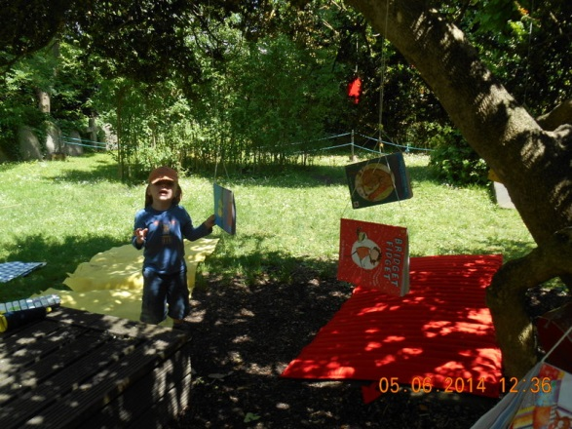

**Forming positive relationships:**

* The team in Acorns pride themselves on making excellent relationships with our parents. If your child has an additional need then we will ensure that we have regular Team around the child meetings, including everybody involved in their care. We will ensure that all information relevant to their care is shared with appropriate people, eg: shared settings, specialists and the staff team.
* We ensure that, if needed, there is daily feedback when you collect your child. We will hold regular meetings to monitor any targets set and we will help you to access any further support available.
* We have an ‘open door’ policy and welcome you in for regular chats and updates, Dena is always available to discuss any concerns you may have.

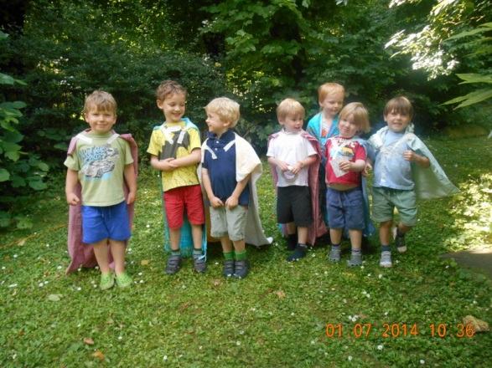

**Communication with other providers:**

* In terms one, three and five we contact all shared nurseries, pre-schools and child minders to discuss the shared children in our care. We then send out our summaries of the child’s learning and development, including any interests or experiences they might have that term, we invite the settings to send us their own summaries to ensure consistency of care.

**Transitions to other settings and school:**

* We have very close links with local schools and have developed positive relationships with school staff to ensure a smooth transition. We also work closely with the Local Authority to discuss children’s needs and to ensure that, if necessary, a detailed transition plan is in place.
* We encourage visits from class teachers, and ensure that any relevant documentation that will support your child in school is shared.
* Where it is felt helpful we will work with you to put together a non-statutory Education Health and Care Plan (MY PLAN)
* Where your child requires a higher level of support we will work with you in requesting a Educational, Health and Care needs assessment, of which the outcome might be a Statutory Educational, Health Care Plan (EHCP) .

**Any other questions:**

If you have any questions or would like to discuss any of the above, please do not hesitate to contact Dena on 445446.

You can access our website at [www.widcombeacorns.org.uk](http://www.widcombeacorns.org.uk)